Lockdown and emergency measures in Europe – current state of play (Update 14/04/2021)
Notes:
- In general, distances of 1.5 metres must be kept as part of physical distance measures. This document only specifies where there are different national requirements.
- In general, masks must be worn in closed public spaces. This document only specifies additional or lesser national requirements.
- Figures for infection rates over the past 14 days per 100.000 inhabitants in countries covered by this document were gathered on 12 April 2021.
- Nightlife establishments are as a general rule closed across Europe, unless specified otherwise.
- As of 08.04.2021, 81,5 million vaccination doses have been administered in the EU.
- Find out more about Coronavirus measures in the USA: https://www.nytimes.com/interactive/2020/us/states-reopen-map-coronavirus.html

Austria  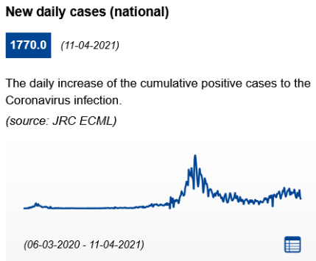 | Infection rate (cumulated past 14 days): 439.82 cases per 100.000 inhabitants (up from 337.76 cases per 100.000 inhabitants on 17.03.2021).  On 12.04.2021, 16,88% of the population received at least one dose of Covid-19 vaccine.  General information: A lockdown is in effect in Austria. A curfew applies from 20:00 to 06:00. In Vienna, as well as from in the provinces of Lower Austria and Burgenland additional measures were in effect from 1 to 11 April. Non-essential shops are closed, museums are closed, and a stay-at-home order is in effect 24/7. People are required to stay at home at all times, and only leave the house for essential reasons, such as professional purposes, medical assistance or supervision.  Travel to the province of Tirol should be limited to essential trips only. First steps towards a reopening have been taken in the province of Vorarlberg, where restaurants and cultural institutions have been allowed to open. From 12 February, a negative COVID-19 test (no older than 48 hours) is required when leaving Tirol.  Non-essential shops are open. However, they were closed in the regions of Vienna, Burgerland and Lower Austria from 1 to 11 April. In all shops, the use of FFP2 masks is mandatory (as well as on public transportation). Opening hours are between 06.00 and 19.00 hours. One customer is allowed per 20 square meters. Personal service providers like hairdressers can open, subject to additional safety measures (FFP2 masks and one customer per 20 square metres). Customers are obliged to show a negative PCR or antigen test that is not older than 48 hours. Between 1 and 11 April, personal care services (e.g hairdressers, massage salons) will close in Vienna, Burgerland and Lower Austria.  In all public places (indoors and outdoors), a minimum distance of 2 metres from each other must be kept. Events are cancelled (with some exceptions such as demonstrations and professional sports). People are asked to keep their social contacts to an absolute minimum. Private gatherings are restricted to no more than two households (4 adults, 6 children). Alcohol cannot be consumed within 50 metres of venues which sell alcohol. This includes petrol stations, bars and restaurants, as well as snack bars and kiosks.  A contact tracing tool Stopp Corona App is available. Protocol for hospitality: Safe hospitality  Hotels: Hotels are closed to leisure travelers and tourists. Only essential travel (e.g. for business that cannot be delayed) is permitted.  Bars and restaurants: Restaurants and bars can only offer take away and home delivery services. Dining in is not permitted. FFP2 masks are required when picking up food. The government has postponed the decision to allow restaurants to open only their terraces and gardens (with guests obliged to present a negative Covid-19 test before entering), initially planned for 27 March.  Only in the region of Vorarlberg, restaurants are allowed to open their terraces and gardens with guests obliged to present a negative Covid-19 test before entering.
Azerbaijan  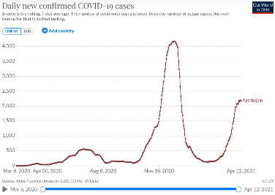  * 2187 new cases recorded on 12.04.2021 | Infection rate (cumulated past 14 days): 294.04 cases per 100.000 inhabitants (up from 76.7 cases per 100.000 inhabitants on 17.03.2021)  On 11.04.2021, 7,48% of the population received at least one dose of Covid-19 vaccine.  General information: The strict lockdown in Azerbaijan have been extended until 01.06.2021. However, some restrictions applied within the strict lockdown, are being eased starting from 18.01.2021 (SMS authorisation requirement to leave home lifted) and from 25.01.2021, restrictions on travel between municipalities have been lifted.  Most businesses and services are open, except for shopping malls. However public transportation will remain frequently suspended in most cities. Since April 5, 2021, educational institutions in Baku, Sumgayit, Ganja, Sheki, and the Absheron district switched to distance learning.  Facemasks are mandatory indoors and outdoors.  Hotels are open. Guests can only leave premises with SMS authorization for essential movements.  Bars and restaurants: activities of on-site customer service in catering facilities, as well as cafes, teahouses and similar establishments) from 06:00 to 00:00 have resumed since 01.02.2021.
Belgium  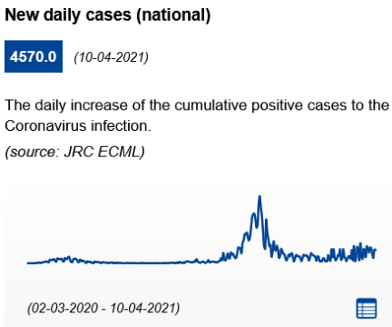 | Infection rate (cumulated past 14 days): 303.34 cases per 100.000 inhabitants (up from 199.62 cases per 100.000 inhabitants on 17.03.2021)  On 11.04.2021, 16,24% of the population received at least one dose of Covid-19 vaccine.  General information: Lockdown measures in place until at least 25.04.2021. There is a nationwide curfew from 00:00 to 05.00. In Brussels there is a curfew from 22.00 to 06.00. Working from home is compulsory where possible. Local authorities have the flexibility and authority to adapt and restrict travel restrictions and non-essential activities in accordance with the epidemiological situation in their area. Lifting of restrictions was considered on 5 March but has been subsequently limited following a resurgence of cases. On 24.03.2021, the federal government decided to reintroduce restrictions affecting schools, non-essential shops, personal care services, and maintained a ban on non-essential travel outside of the country. At the time of writing, new measures may be announced on 14.04.2021.  Full-time face-to-face education was suspended from 29 March to 2 April. If possible, pupils in secondary schools will return to school full-time after the Easter break on Monday 19 April.  Wearing a mask is mandatory in most public spaces and strongly recommended elsewhere. It is mandatory to wear a facemask in all outdoor and indoor public spaces in Brussels. Gatherings in public spaces are limited to four people. At home, people can receive maximum one visitor from outside the household.  Non-essential shops may only receive customers by appointment. The maximum number of customers allowed inside simultaneously depends on the size of the shop and is capped at a maximum of 50 people irrespective of size. Home deliveries and click-and-collect remain possible provided that there is no physical contact and the shop is not entered. It is prohibited to sell alcoholic beverages after 20.00. Nightshops must close at 22.00, and they will also have to stop selling alcoholic beverages after 20.00. Most personal care services reopened on 13.02.2021 but closed again on 27.03.2021.  Hotels: Accommodations (hotels, B&B's etc.) may be open, with the exception of their restaurants, bars and communal facilities (pool, fitness). Guests are only allowed to have meals in their room. Holiday parks (campsites, bungalow parks) were allowed to reopen on 08.02.2021.  In Brussels, a safety label has been developed to reassure visitors that the site, venue or establishment in question is safe. The criteria for receiving such a label are based on checklists drawn up on the basis of specific protocols, developed in close cooperation with sectoral entities and representatives. Information for the other regions is available at: Health protocols for Flanders (in Dutch); Health protocols for Wallonia (in French).  Bars and restaurants: Restaurants, bars and cafés are closed. Take away meals and deliveries are permitted until 22.00. It is forbidden to sell alcoholic beverages after 20.00. The government aims to reopen bars and restaurants in May 2021.
Bulgaria  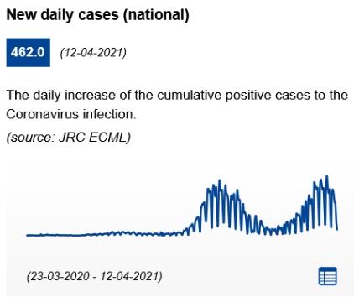 | Infection rate (cumulated past 14 days): 617.71 cases per 100.000 inhabitants (up from 551.023 cases per 100.000 inhabitants on 17.03.2021)  On 12.04.2021, 6,70% of the population received at least one dose of Covid-19 vaccine.  General information: No curfew, but social distancing and restrictive measures are in place. Teleworking is recommended whenever possible and face-to-face school lessons are suspended. There is no interdiction to move within the country.  Non-essential shops are open but visits to shopping centres are suspended as well as visits to stores with a net retail area of over 300 square metres offering non-food items. However, shopping centers should reopen from the 16.04.2021.  The holding of public events (e.g. conferences, seminars, competitions, etc.) is suspended. The ban does not apply to competitions held under the Labor Code, the Civil Servant Act, the Academic Staff Development Act and other special laws. All cultural and entertainment events (namely film screenings, theatre shows, stage events, concerts, exhibitions, dance classes, creative and musical arts, etc.) are suspended, including those held outdoors (e.g. fairs, festivals, etc.). Group celebrations of a private nature are allowed with the presence of no more than 15 participants. The organization of excursions and group visits to tourist sites is suspended.  ViruSafe is used to track and trace through a daily tracking for symptoms and health status with a voluntary GPS-based functionality. Health protocols for tourism services and tourists (in English).  Hotels are open. Only the room service is allowed in the case of catering establishments.  Bars, restaurants and cafés: From 12.04.2021 to 30.04.2021, restaurants and entertainment are open when using no more than 50% of their capacity and limited working hours between 6.00 and 23.00. From 29.04.2021 discos, bar clubs, piano bars, bar bars and night bars are open when using no more than 50% of their capacity and wearing face masks by staff.
Croatia  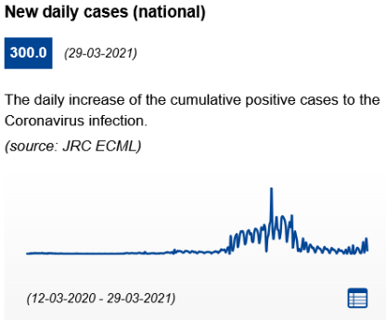 | Infection rate (cumulated past 14 days): 133.28 cases per 100.000 inhabitants (up from 83.9 cases per 100.000 inhabitants on 17.03.2021)  On 12.04.2021, 11,79% of the population received at least one dose of Covid-19 vaccine.  General information: Restrictions on free movement in the country were lifted on 08.01.2021. Local and regional containment measures can be applied, based on the epidemiological situation.  Physical distancing of 2 meters indoors. There are maximum 25 people allowed at public events. At private gatherings and ceremonies maximum 10 people can attend. Shops are open, but the general public health recommendations on physical distancing, personal hygiene and disinfection should be maintained. Cinemas, museums, theatres, professional artistic projections/exhibitions/performances are limited to 25 people. Establishments should close at 22.00. Public events can last until 20:00. There is a ban on the sale of alcohol from 22.00 to 06.00.  On July 2020 the government launched the STOP COVID-19 app. Croatia travel information and general measures  Hotels: Following the general public health recommendations on physical distancing, personal hygiene and disinfection, these services are open. Accommodations can only cater or serve guests who are staying in the accommodation. For more details: recommendations for hotels and renters  Bars and restaurants: Restaurants, bars and cafés are allowed to serve in outdoor spaces, and to offer take-away and delivery services. Times of operation are between 06.00 and 22.00 hours.
Cyprus  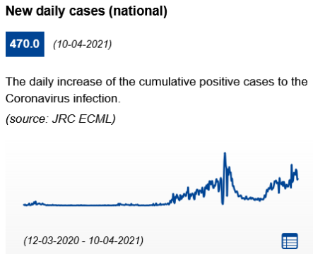 | Infection rate (cumulated past 14 days): 784.79 cases per 100.000 inhabitants (up from 380.14 cases per 100.000 inhabitants on 17.03.2021)  On 09.04.2021, 14,95% of the population received at least one dose of Covid-19 vaccine.  General information: As of 10.01.2021, a strict lockdown is applied. A curfew is in place and the movement of citizens is banned from 23:00 (since 16 March, previously 21:00) to 5:00. Movements are prohibited within the country. As of 16 March, the percentage of physical presence of employees in private service businesses decreases from 50% to 25%.  Facemasks required in outdoor public spaces. Social distancing measures of 2 meters outdoors and 3 meters indoors are in place. It is recommended to remain within the same social bubble. From 08.02.2021, the presence of a maximum of 4 people in a residence (beyond those residing permanently) is permitted. However as of 15.03.2021, access to public gathering areas such as playgrounds, church courtyards, courtyards of other places of religious worship, dams, excursion and camping sites, marinas and/or other similar areas is prohibited.  As of 01.02.2021, retail shops, including department stores and shopping centre, are allowed to re-open, as well as personal care services. As of 01.03.2021, street vending and flea markets other than food are allowed. Tracing app : COVTRACER  Hotels: The operation of hotels or/and tourist accommodation units shall be permitted provided that they accommodate exclusively people who do not reside in the Republic, as well as for the accommodation of people in mandatory isolation. Catering areas inside hotels and tourist accommodation establishments may function until 22:45, serving only the guests staying in their premises, with a maximum number of people based on the available space and in general the following measures apply: the public shall exclusively be served at table arrangements; table reservations may not exceed 6 people; the operation and use of bars in catering establishments is limited exclusively to the preparation of food or drinks by the employees and the direct service from the bar is prohibited. After 22:45 only the delivery service is available. the maximum number of people allowed is 40 in indoor areas and 80 in outdoor areas, provided that a capacity of 1 person/3 square metres indoors and 1 person/2 square metres outdoors is maintained.  Catering services at the Airports of Larnaka and Pafos are allowed to operate until 22:45.  For more details: recommendations for hotels and renters  Bars and restaurants: Since 15.03.2021, restaurants may reopen their outdoor seating areas. The public may be served only while sitting down at a table. The number of people is determined according to the square metres of each establishment and provided that the distancing rules are applied. The maximum number of people per table at catering establishments (outdoor areas) is 8, irrespective of age. Home delivery and take-away are allowed (until 20:30). As of 21:00, only home delivery is allowed.
Czech Republic  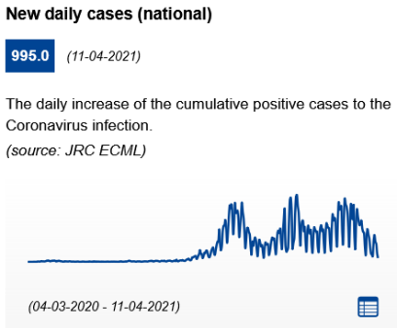 | Infection rate (cumulated past 14 days): 604.82 cases per 100.000 inhabitants (down from 1452.9 cases per 100.000 inhabitants on 17.03.2021)  On 12.04.2021, 13,13% of the population received at least one dose of Covid-19 vaccine.  General information: There are 5 alert levels in the Czech anti-epidemic system. As of 27.12.2020, Czechia has entered the highest level of restrictions (level 5). An extended night curfew (between 21:00 and 04:59) is in place). In the time-slot between 05:00 and 20:59, it is anyway only possible to go out for basic needs (visiting friends or close parents, doing the shopping, travelling to work, etc.).  As of 25.02.2021, any person from the age of 15 is required to wear a respirator without an exhalation valve with a filtration effectiveness of at least 95% in accordance with the relevant standards (e.g. FFP2/KN 95) in the indoor space. Social distancing of 2 meters in all establishments. Social gatherings are restricted to 2 people, both indoors and outdoors, with some exceptions, for example in the case of members of the same family. The right of organizing a demonstration is allowed with the maximum presence of 100 people in clusters of 20, maintaining a distance of at least 2 meters between each cluster. All participants must wear a face mask or other kinds of respiratory protection devices.  As of 18.12.2020, only essential shops are allowed to be open, hosting 1 customer/15 square metres and a group formed by no more than 2 people (excluding children under 15 years old), ensuring the maintenance of a safety distance of 2 metres between them.  General safety measures for establishments: https://koronavirus.mzcr.cz/wp-content/uploads/2020/05/specifikace_pokyny_2505.pdf. Recommended tracing app: eRouška. A system called "smart quarantine" is in place.  Hotels: The operation of hotels and other accommodation services is limited. Accommodation services can be provided only for: business-related purposes; individuals who are required to stay in quarantine or self-isolation; foreigners before their departure from the Czech Republic; foreigners with valid work permit in the Czech Republic. Hotel restaurants can be open for guests between 5:00 and 20:59. During opening hours, guests must be seated, with a distance of at least 1.5 m between people of different tables. A maximum of 4 people can sit at the same table, if they are not members of the same household, while more than 4 people can sit at long tables. The total occupancy may not exceed 50% of the total restaurant.Find out more: Accommodation facilities  Bars and restaurants: Catering establishments are temporarily closed, but the takeaway option can be in function between 05:00 and 20.59, while home delivery is in function without time limits. Alcohol consumption at publicly accessible locations is prohibited. People who consume meals in the vicinity of the catering establishment, including beverages, are required to keep a distance of at least 2 metres from the others unless they are members of the same household. Find out more: Restaurants
Denmark  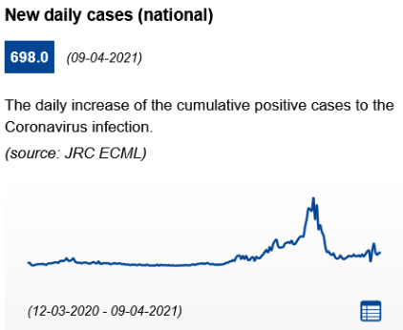 | Infection rate (cumulated past 14 days): 67.84 cases per 100.000 inhabitants (up from 44.3 cases per 100.000 inhabitants 17.03.2021)  On 11.04.2021, 15,25% of the population received at least one dose of Covid-19 vaccine.  General information: A nationwide lockdown is in force and stricter measures have been applied to the whole country. A series of national measures will apply until the end of 05.04.2021. Younger pupils were allowed to return to school on 08.02;2021.  Masks are mandatory for over-12s in all closed spaces open to the public. General social distancing requirement of at least 2 meters. The Danish police can introduce a temporary ban on loitering if too many people are gathered in the same place. The maximum number of people who can gather continues to be five people indoors and 10 people outdoors. On the island of Bornholm, 10 people can gather indoors and outdoors. Citizens are strongly urged to hold events, parties and celebrations at private homes for nobody else but close family members and friends and end parties by 22:00.  As of 06.04.2021, personal services reopened with the requirement to implement measures to prevent the spread of COVID-19 (Presentation of Corona passport). As of 06.04.2021, further reopening of schools and higher education is accommodated nationwide.  Non-essential shops are open with strict health and hygiene requirements. Shops and stores allowed to stay open must observe specific restrictions. As of 15.03.2021, stores above 5000 square metres can open for 250 customers at the same time. Cultural facilities (including theatres, concert halls, museums, music venues, art exhibitions, cultural centres, cinema, libraries, etc.) must keep indoor facilities closed to the public. Outdoor cultural institutions such as zoological gardens can reopen with the precondition that visitors provide a negative COVID-19-test not older than 72 hours.  Recommended contact tracing app: smittestop.dk. Health protocols for tourism services and tourists  Hotels are allowed to remain open. It is normally prohibited to organise or attend events, activities etc. with more than five people at or in a hotel. However, if all the people attending an event etc. are members of the same household or each other's closest relatives, up to 10 people can attend simultaneously. Horesta has developed a ’Safe to Visit’ label.  Bars and restaurants: Establishments selling food, drinks or tobacco for on-site consumption must keep their premises and locations closed to the public However, restaurants, bars and similar establishments are allowed to stay open to the public during this period to sell food and drinks (except alcoholic drinks with an alcohol concentration of 1.2% or more from 10.00 pm to 5.00 am) not consumed on-site (takeaway or delivery) if they have the requisite licences under other relevant legislation. The same applies to restaurants etc. selling takeaway food or drinks and located in shopping centres, arcades or bazaars.
Estonia  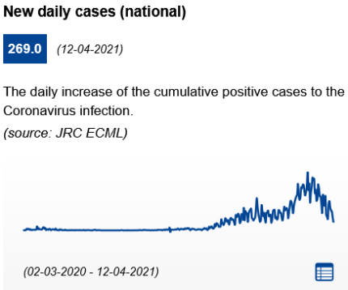 | Infection rate (cumulated past 14 days): 772.1 cases per 100.000 inhabitants (down from 1541.42 cases per 100.000 inhabitants on 17.03.2021)  On 11.04.2021, 19,53% of the population received at least one dose of Covid-19 vaccine.  General information: The government introduced stricter measures until at least 25.04.2021. The government will decide on the need to further extend the restrictions around mid-April. The existing restrictions will remain in force in all areas.  All public indoor spaces are prohibited. Distance learning is the general rule for education establishments. In addition to the restrictions, the government very strongly recommends that organising private parties be avoided and contacts with other people be reduced to a minimum. If a meeting is urgent, no more than six people should participate at it at once.  No more than two people can be together, keeping a distance of at least 2 metres from others (2+2 rule). Since 11.03.2021, the 2+2 rule is in place in all spaces, both indoors and outdoors  Non-essential shops are open with specific limitations. Notably, at least 25 square metres per customer must be ensured. Essential stores must ensure maximum 25% occupancy requirement.  Recommended contact tracing app: HOIA. Information published by the Health Board are available at: Health protocols for tourism.  Hotels: Tourist accommodations are open to visitors, with precaution methods and processes in order to ensure people safety.  Bars and restaurants: Restaurants, bars and cafés can only serve take away services. The nationwide restriction on the sale of alcohol is in place is extended until the 30.04.2021. According to this, late-night alcohol sales is forbidden from midnight to 10:00 where alcohol is sold for consumption on the spot (for example: bars, nightclubs, restaurants, theatre buffets and hotels).
Finland  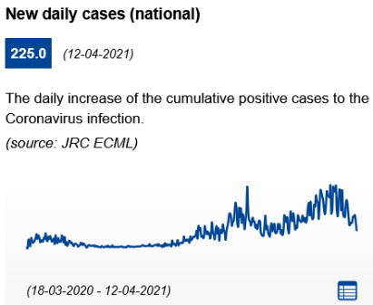 | Infection rate (cumulated past 14 days): 106.07 cases per 100.000 inhabitants (down from 168.49 cases per 100.000 inhabitants 17.03.2021)  On 12.04.2021, 20,47% of the population received at least one dose of Covid-19 vaccine.  General information: No curfew or restrictions on free movement. The Ministry of Social Affairs and Health has updated the action plan for implementing the Government’s strategy to combat COVID-19. The plan covers the period from January to May 2021, and it can be revised during the spring if the epidemiological situation so requires. The COVID-19 action plan divides the epidemic into three phases (applied at the regional level): baseline, acceleration phase and community transmission phase. Regions apply diverging restrictions based on the phase determined.  The use of masks in public transportation and among the public in areas that experienced covid-19 cases within the last 14 days is recommended. Maintaining physical distance of 1-2 metres is recommended. The restrictions and recommendations concerning events, gatherings and meetings differ from one region to another depending on the phase of the epidemic. The regional state administrative agencies will assess the adequacy of the restrictions and limit e.g. customer numbers at the local level as necessary number of persons at public events restricted to half (50 per cent) of the normal capacity  Non-essential shops are open with the following safety measures: limitation of the number of visitors, physical distancing and guidance on personal hygiene. The restrictions and recommendations concerning events, gatherings and meetings differ from one region to another depending on the phase of the epidemic (stable phase, acceleration phase, or community transmission). The guidelines on good hygiene and safe distances are in force at all phases.  Health protocols for domestic tourism are available: Guidelines. Recommended contact tracing app: Koronavilkku.  Hotels are open but many are forced to keep their services closed due to lack of customers as well as financial reasons.  Bars and restaurants: are allowed to open, as well as nightlife establishments. In restaurants throughout Finland customers must have their own seat.  In ‘baseline’ areas, establishments must stop serving alcoholic beverages by midnight, and establishments that primarily serve alcoholic beverages must close by 01.00. Food and beverage service establishments may be open round the clock. There are no restrictions on the number of customers. In ‘acceleration‘ and ‘community transmission’ areas, establishments must stop serving alcoholic beverages by 22.00 and close at 23:00 (24:00 in ‘acceleration’ areas), and pubs, bars and nightclubs may allow half the normal number of customers in the premises at a time. Restaurants and cafes may allow three quarters of the normal number of customers in the premises at a time.
France  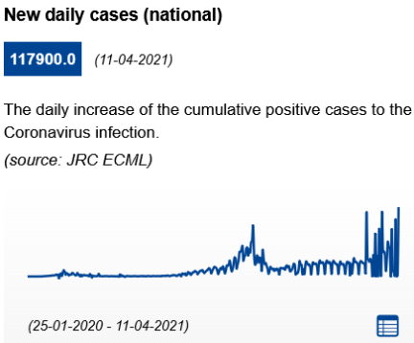 | Infection rate (cumulated past 14 days): 766.12 cases per 100.000 inhabitants (up from 572.95 cases per 100.000 inhabitants on 17.03.2021)  On 11.04.2021, 15,87% of the population received at least one dose of Covid-19 vaccine.  General information: A nightly curfew is currently in force in metropolitan France. Between 19:00 (as of 20.03.2021, previously 18:00) and 6:00 you may leave your residence only for essential reasons and with an exemption certificate. Teleworking should be in place whenever possible. As of 26 March 2021, stronger containment measures are implemented in 19 departments (incl. Paris). From 04.04.2021, the strengthened rules already in force in 19 departments are extended to the whole continental territory of France for 4 weeks.  As a general rule, it is possible to leave home within a radius of 10 km around the residency, provided that proof of address is available in case of request. In the case of travel within a radius of more than 10 km (within the department or for inter-regional travel), a special travel certificate is required. Inter-regional movements are prohibited on the entire territory, except the ones required for compelling and professional reasons. The prefects are also invited to prohibit or regulate access to certain crowded sites during the weekends.  Furthermore, facemasks are compulsory in enclosed public places. Furthermore, wearing a mask is also compulsory for anyone over 11 years old in all public spaces, public transport, in crowded areas. A physical distancing of at least 1 metre applies in all places and circumstances. Gatherings with more than 6 people are prohibited. Exceptions apply in case of professional meetings, transport services, funerals (within the limit of 30 people). Social gatherings are banned.  Only schools and essential shops, including bookstores, will remain open. These shops must close at 7pm. Travel from these areas is heavily restricted. Cultural venues such as museums and higher education establishments remain closed.  Health protocols for tourism services and tourists. TousAntiCovid is available since 2/6/2020. The App allows the user to be notified of possible close contact (less than 1 metre for at least 15 minutes) with someone who has then been tested positive to Covid. "  Hotels can remain open but must close their catering facilities, room-service only.  Bars and restaurants remain closed. Delivery is authorised around the clock; take-away services possible until 19:00.
Georgia  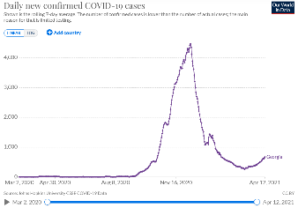  * 670.57 new cases recorded on 18.03.2021 | Infection rate (cumulated past 14 days): 207.63 cases per 100.000 inhabitants (up from 114.41 cases per 100.000 inhabitants on 17.03.2021)  On 12.04.2021, 0,52% of the population received at least one dose of Covid-19 vaccine.  General information: A curfew remains in place from 9pm to 5am, where public and private transportation, including walking, is not permitted, unless it is for an essential need (for example, medical services). Inter-city transport resumed on 25.02.2021. Face masks are mandatory in all closed spaces and outdoor public areas. Enforcement of regulations on social distancing and masks has been tightened. No more than 10 people can participate in social gatherings, indoor or out. Working from home is recommended where possible.  Open and closed markets in all cities of the country resumed operation from 15.02.2021. Museums and gyms have re-opened; theatres will re-open from 01.04.2021.  On 08.03.2021, non-food retailers-both malls and marketplaces-will start operating on weekends as well.  Aerial lifts in mountain resorts reopened on 08.03.2021.  Hotels, bars and restaurants: Some hotels and other rental accommodation remain open on 25.02.2021, for example in mountain resorts, but many are closed.  Bars and restaurants: Indoor restaurants have re-opened. Delivery/drive-through services operate every day of the week.
Germany  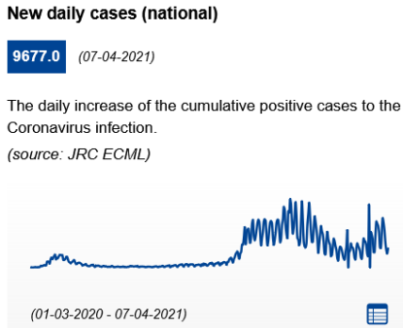 | Infection rate (cumulated past 14 days): 264.9 cases per 100.000 inhabitants (up from 169.03 cases per 100.000 inhabitants on 17.03.2021)  On 12.04.2021, 16,19% of the population received at least one dose of Covid-19 vaccine.  General information: Specific regulations for each federal state are available at the Federal Tourism Competence Centre. The current lockdown has been extended until the 18.04.2021. All citizens are urged to refrain from non-essential travel within Germany and abroad. States are to limit the movement radius for non-essential purposes of residents to 15 kilometers around their homes, in counties that have registered more than 200 infections per 100 000 people within seven days.  From 08.03.2021: in areas where the infection rate is between 50 and 100 infections per 100 000 inhabitants in seven days, museums, galeries and zoos can open under strict conditions (reservation, time slot, documentation). If the infection rate drops below 50 infections per 100 000 inhabitants in seven days, museums, galeries, and zoos can open with less restrictions.  ‘Medical grade’ facemasks should be used in public closed spaces for all citizens above 6 years old, as well as masks outside shops where queues are formed and in car parks. Personal contacts between households must be restricted to an “absolute minimum”. Personal contacts between households must be restricted to an “absolute minimum”. Meetings beyond one's own household, are restricted to one other person. From 08.03.2021, one houeshold can visit one other household. Each federal state can set specific rules for the maximum number of people that are allowed to meet together, with different limits applicable to indoor and outdoor spaces.  Retail stores, with the exception of grocery stores and shops to meet daily needs, are to remain closed. From 08.03.2021, book shops, garden centers and flowers shops can open. In areas where the infection rate is between 50 and 100 infections per 100 000 inhabitants in seven days, more shops are allowed to open, although under strict conditions (reserved time slot).  Recommended contact tracing app: Corona-Warn-App  Hotels: Hotel stays for touristic purposes are prohibited. Details on the current restrictions in the federal states are available on the tourism guide.  Bars and restaurants: Restaurants, bars and cafés are closed (except for delivery and take-away). Details on the current restrictions in the federal states are available on the tourism guide. Regional restrictions on authorised hours for alcohol sales are commonplace.
Greece  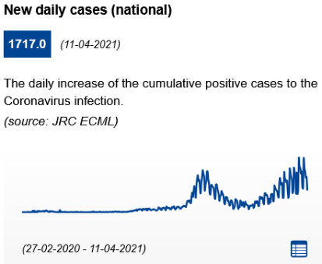 | Infection rate (cumulated past 14 days): 386.49 cases per 100.000 inhabitants (up from 279.43 cases per 100.000 inhabitants on 17.03.2021)  On 12.04.2021, 14,20% of the population received at least one dose of Covid-19 vaccine.  General information: A general nationwide lockdown is imposed. Citizens in need of going out for essential reasons will have to notify it and to provide specific certificates according to the reasons for their movement. Citizens must also carry identification. There is also a ban on travelling outside home prefectures, except for essential reasons. Furthermore, a curfew is in place between 21:00 and 05:00. Authorities have divided the country into "red" and "yellow" areas (in "red" areas additional restrictions apply). This is reviewed on a weekly basis.  The use of facemasks is mandatory both indoors and outdoors. Gatherings with 4 or more people are not allowed. Individual sport with a maximum number of three people is allowed. Special social distancing rules have been set for a wide range of places.  Retail shops are temporarily closed, except for supermarkets, pharmacies, food delivery stores and in hospitals.  Hotels: Tourism accommodations remain open under specific hygiene protocols. Safety protocols for tourism services.  Bars and restaurants are temporarily closed. However, home delivery and takeaway services are available also between 21:00 and 05:00, within the permitted movements during these hours.
Hungary  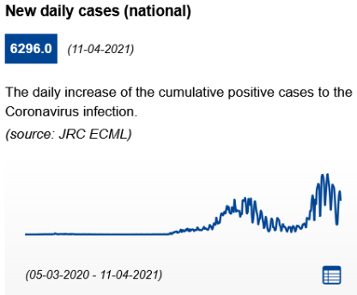 | Infection rate (cumulated past 14 days): 883.1 cases per 100.000 inhabitants (up from 821.37 cases per 100.000 inhabitants on 17.03.2021)  On 12.04.2021, 30,74% of the population received at least one dose of Covid-19 vaccine.  General information: Thanks to the progress of the vaccination, the government has decided on 07.04.2021 to start lifting the restrictions gradually and responsibly. As of 07.04.2020, the curfew has been delayed from 22:00 (initially 20:00) to 5:00 and only essential movements are allowed within a 500 metre radius. Teleworking is recommended. Kindergartens and primary schools will reopen on 19.04.2021.  Mask wearing is mandatory in in all outdoor and indoor public spaces. All gatherings are forbidden. A general ban on events has taken effect .Up to 10 people can attend family and private events.  As of 07.04.2021, non-essential shops, which has been closed since 08.03.2021, reopened between 5:00 and 21:30 provided that a capacity of 1 customer/10 square metres is observed.  Guidelines available for tourism services: The Covid manual of the Hungarian Tourism Agency and Reccommendations for reopening restaurant terraces and gardens. Recommended contact tracing app: VirusRadar  Hotels: Tourism accommodations remain open only for guests arriving for business, economic or educational purposes. Safety and hygiene measures are in place, wearing a face mask is mandatory as well as maintaining a safety distance of 1.5 metres at least.  Restaurants and bars are to remain closed. Guests may enter the restaurants exclusively for the purpose of dispensing and transporting takeaway food for the necessary period.
Iceland  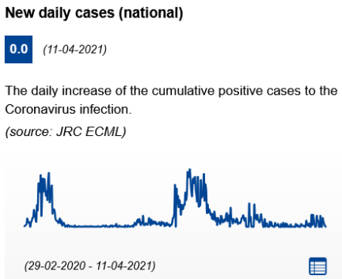 | Infection rate (cumulated past 14 days): 26.71 cases per 100.000 inhabitants (up from 8.68 cases per 100.000 inhabitants on 17.03.2021)  On 12.04.2021, 17,91% of the population received at least one dose of Covid-19 vaccine.  General information: New restrictions announced by the government entered into force on 25.03.2021 and remain in effect until 15.04.2021. The changes mainly relate to gathering. Facemasks must be worn wherever a social distance of 2 metres cannot be respected.  Regarding gatherings, the maximum number of people allowed in the same location is 10, with certain restrictions, both in public and private locations. This limit, however, does not apply to persons in the same household.  Stage performances, cinema showings and other cultural events will be permitted with up to 30 persons on stage; this applies to both rehearsals and performances. Up to 50 audience members may be admitted; they shall be seated, and must use face-masks  Non-essential shops are open and may accept 5 persons for each 10 m2 of space and may have up to 50 customers in their premises, as long as it is possible to ensure at least 2 metres between persons who are unrelated. Hairdressers, beauty salons and fitness centres are closed.  From April 6, 2021, all travelers – regardless of origin – are welcome to visit Iceland if they can show either a certificate of full vaccination against COVID or a certificate of previous COVID infection.  Recommended tracing app : Rakning C-19  Hotels: are allowed to remain open. Health protocols for tourism.  Restaurants: Are open. Restaurants licensed to serve alcohol, including bars and nightclubs, may stay open to 22:00 every day, but must comply with the 20-person limit and the two-metre social-distancing rule between unrelated persons. New guests may be admitted until 21:00. Only seated guests may be served. Take-away meals may be served until 23:00. Food may be served in buffets, but guests shall be obliged to sanitise their hands before going up to the buffet table and also after doing so. They shall also wear face-masks and observe the 2-metre distancing rule when approaching and leaving the table.  Bars and nightclubs: remain closed.
Ireland  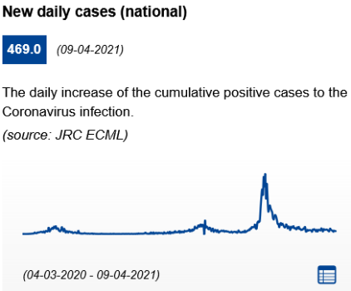 | Infection rate (cumulated past 14 days): 139.98 cases per 100.000 inhabitants (stable from 143.26 cases per 100.000 inhabitants on 17.03.2021)  On 11.04.2021, 15,18% of the population received at least one dose of Covid-19 vaccine.  General information: Despite some easing of measures from the 12.04.2021, Ireland remains on level 5 according to its Plan for living with COVID-19.  It is permitted to meet 1 other household outside but not in the garden. It is permitted to travel within your county or within 20km of your home if crossing county boundaries. It is mandatory to work from home when possible.  Social distancing requirement of 2 meters.  All retail is closed except for essential retail. All non-essential services are closed. Click and collect from non-essential retail outlets should be discontinued. Click and deliver will continue to be permitted. The government will consider the phased return of non-essential retail commencing with click and collect and outdoor retail, after 4 May.  All cultural venues are closed. This will be reviewed by 4 May.  For those working in the tourism sector, Fáilte Ireland (National Tourism Development Authority) has published a set of operational guidelines for businesses to assist them reopen safely. COVID Tracker can be downloaded at www.gov.ie  Hotels: Open only for essential non-social and non-tourist purposes.  Bars and restaurants are closed. Take away food and delivery only. Wet pubs are closed.
Italy  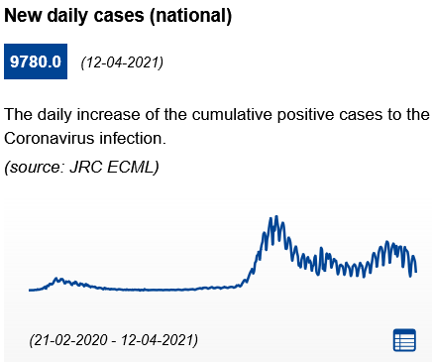 | Infection rate (cumulated past 14 days): 388.73 cases per 100.000 inhabitants (down from 506.19 cases per 100.000 inhabitants on 17.03.2021)  On 12.04.2021, 15,38% of the population received at least one dose of Covid-19 vaccine.  General measures: The state of emergency has been prolonged until 30.04.2021. Restrictive measures vary according to the epidemiological level of each Italian Region. The Prime Ministerial Decree of 02.03.2021 contains further stringent measures to counter the spread of the new coronavirus. The decree confirms the subdivision of the national territory in four main areas, corresponding to four risk scenarios, for which modular measures are envisaged: white (low risk), yellow (medium risk), orange (high risk) or red (very high risk). Stricter measures are to be in place from 15 March to 2 April 2021 and from 6 to 30 April 2021, where the provisions for the orange zones apply in all the yellow zones.  In the red zone, only essential movement (health and work-related ones) are allowed. In the orange zone, it is allowed to move within your municipality, between 5.00 and 22.00. An auto declaration is required in order to go out during the curfew hours and in the case of red and orange areas. The ban on travelling between regions is confirmed until 30.04.2021. Returning to one's residence, domicile or home is still allowed, as well as travel motivated by work requirements, health reasons or immediate necessities. Streets or squares, where gatherings are more likely to happen, can be closed to the public from 21:00.  It is mandatory to always bring a facemask and wear it outdoors from 6 years old, with the exception of places where the condition of isolation from other people is guaranteed. Physical distancing of 1 meter (2 meters for sports activities). Gatherings are not allowed in public spaces. The consumption of food and drink in public places and places open to the public is prohibited from 18:00 to 05:00.  In orange and yellow zones, the opening to the public of all commercial activities is allowed until 21:00, provided that the interpersonal distance of at least 1 metre is ensured. The activities of non-essential shops and markets are suspended in red zones nut the delivery of products is allowed. The activities of gyms, swimming pools, spas prohibited nationwide.  Recommended contact tracing app: https://www.immuni.italia.it/  Hotels: the activities of accommodation facilities (hotels, non-hotels, short-stay and farm holiday hotel accommodations) are allowed, provided that the interpersonal safety distance of 1 metre is guaranteed in the common areas and strict hygiene measures are in place. Catering in hotels and other accommodation facilities is allowed without time limits, exclusively to its customers. Guidelines for accommodation  Restaurants and bars: are closed in orange and red areas. Delivery and take-away services are allowed until 10 p.m for restaurants. Take-away service is prohibited for the activities of bars/cafés after 18:00, as well as for other commercial activities of the same type.  In the case of "white areas", catering establishments are allowed to re-open without restrictions in place, with the only requirements to wear a facemask and follow social distancing and hygiene rules. Find out more one Guidelines for restaurants.
Latvia  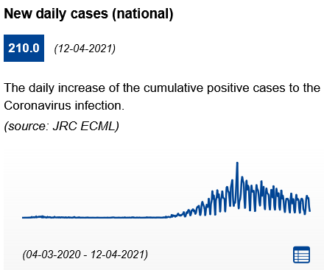 | Infection rate (cumulated past 14 days): 344.33 cases per 100.000 inhabitants (down from 376.78 cases per 100.000 inhabitants on 17.03.2021)  On 12.04.2021, 8,15% of the population received at least one dose of Covid-19 vaccine.  General information: Curfew measures were lifted on 11.02.2021. Only employees whose duties cannot be performed remotely due to the nature of their work are allowed to work on site.  The use of masks is mandatory in indoor public settings, and outdoor areas that are adjacent and part of a given facility for all people above 7. People must respect 2 metres physical distancing. Public events are not allowed. Private events are also prohibited, with the exception of events within a single household.  As of 08.02.2021, restrictions on retail shops began to be lifted. All stores (with a total sales area under 7000 m2) outside shopping centres are allowed to operate. Shops must display clear instructions regarding physical distancing and current safety measures and ensure at least 25 square metres per customer. From 01.03.2021, subject to enhanced safety measures, it is permitted to provide manicure, pedicure, podiatrist, and hairdresser services, as well as individual open-air photo services.  Regarding gatherings, up to 10 people can meet together outdoors and up to 2 households (maximum 10 people) can privately meet outdoors.  Recommendations for tourism available here: Latvia travel recommendations. Recommended contact tracing app: Apturi  Hotels can stay open on the condition that physical distancing and epidemiological safety measures are being followed. By complying with recommendations, including disinfection of surfaces and others, hotels and guest houses can operate and admit guests.  Restaurants and bars can only provide take-away and delivery services.
Liechtenstein  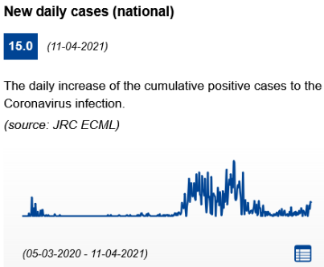 | Infection rate (cumulated past 14 days): 247.54 cases per 100.000 inhabitants (up from 101.62 cases per 100.000 inhabitants on 17.03.2021)  No information available on vaccination status.  General information: Working from home is strongly encouraged. Masks are required inside all public buildings. Operators of publicly accessible facilities and businesses, and organisers of events, must draw up and implement a protection concept. The protection concept must provide for measures concerning hygiene and distance for the facility or event. The protection concept may include an obligation to wear a mask if a physical distance of 1.5 metres cannot be respected.  All events, with the exception of religious events, funerals and political events with a maximum of 50 participants, will be suspended. Private events and any form of gathering in public spaces are limited to 10 people. All facilities and businesses in the areas of culture, entertainment, recreation and sports are temporarily not allowed, except for outdoor sports activities.  Non-essential shops and personal care services are allowed to remain open.  Health safety protocols for hotels and restaurants are available on the website www.lhgv.li.  Hotels are open in compliance with hygiene and safety guidelines. Restaurant operations for hotel guests must be based on a protection concept. There is an obligation to wear a mask based on the hygiene regulations.  Bars and restaurants are closed.
Lithuania  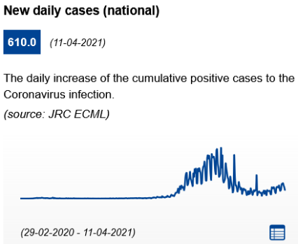 | Infection rate (cumulated past 14 days): 444.42 cases per 100.000 inhabitants (up from 235.67 cases per 100.000 inhabitants on 17.03.2021)  On 12.04.2021, 18,10% of the population received at least one dose of Covid-19 vaccine.  General information: National quarantine remains in effect until 30.04.2021. People should leave their residences and municipalities only for essential purposes. Police controls the movement between municipalities. From 16.03.2021 until 30.04.2021, movement will be restricted in the several municipalities including the Vilnius district. Travelling to and from these municipalities will not be allowed.  Protective face masks are mandatory in all closed public places. Social distancing rule of 2 meters. As of 06.03.2021, it is allowed to be in open public places in groups of maximum 5 persons or in groups of two members of a family and/or two members of a household.  From 15.03.2021, it will be allowed to reopen stores and pavilions (except complex of roofed pavilions in marketplaces) that have a direct access from the outside for customers or a separate entrance used solely by the customers of that store or pavilion, and kiosks. It will not be allowed to reopen stores, including those in shopping and/or entertainment centres, marketplaces and other public points of sale.  Recommended contact tracing app: Korona Stop LT  Hotels: The accommodation sector is required to accommodate a maximum of 2 people in one room, except for family members; to ensure that everyone wears a face mask and maintains a distance of at least 2 meters between people or groups of people (up to 5 people or family members) in common areas. It is prohibited to lease, sublease or lend premises intended for accommodation services (owned by both natural and legal persons by the right of ownership or other legal grounds) for holding private events, parties and other gatherings.  Bars and restaurants are closed, except for take away or delivery. Catering can still be provided in certain circumstances such as for staff of enterprises, or in educational institutions, social care, and health care.
Luxembourg  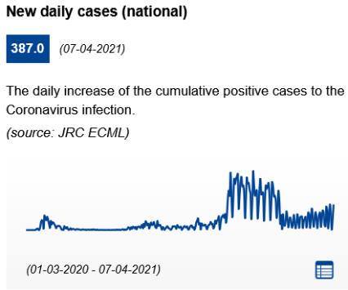 | Infection rate (cumulated past 14 days): 227.56 cases per 100.000 inhabitants (stable from 225.28 cases per 100.000 inhabitants on 17.03.2021)  On 12.04.2021, 15,34% of the population received at least one dose of Covid-19 vaccine.  General information : Current lockdown measures in place were adopted on 26.11.2020. Between 23:00 and 6:00 a curfew is in place and only essential movement is allowed  Facemasks (any protection covering nose and mouth) are mandatory in all closed public areas and in all outdoor public areas and when more than 4 people are gathered. Social distancing of 2 meters if more than four people are present. Households may receive a maximum of 2 guests. Gatherings of over 100 people are prohibited. The assignment of seats is compulsory for gatherings of more than 10 and up to 100 people.  Non-essential shops and personal care services are open; any commercial establishment with a sales area equal to or bigger than 400 square metres, which is accessible to the public, is subject to a limitation of one customer per 10 square metres of the sales area; if the sales area is less than 20 square metres, a maximum of 2 guests is authorised. The consumption of alcohol in the public space and in public areas is prohibited. Institutions of the cultural sector (including theatres, cinemas, museums and libraries) are open to the public, with a maximum of 100 people allowed to gather.  Health protocols for tourism services and tourists (in English).  Hotels and other accommodation facilities remain open. Catering remains restricted to the room service.  Bars and restaurants: As of 07.04.2021, outdoor catering services are open to public from 6am to 6pm. This measure does not concern school and university canteens. Take-away, drive-through and home delivery services are also still available. Sanitary measures for restaurants and bars
Malta  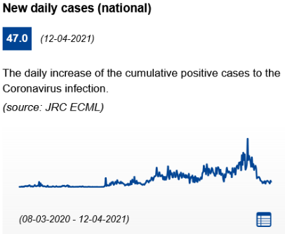 | Infection rate (cumulated past 14 days): 146.49 cases per 100.000 inhabitants (down from 795.68 cases per 100.000 inhabitants on 17.03.2021)  On 12.04.2021, 39,23% of the population received at least one dose of Covid-19 vaccine.  General information: Measures imposed to limit the spread of COVID-19 were tightened in Malta from 05.03.2021. It will start lifting the restrictions from 12.04.2021.  The use of face masks is obligatory in all indoor and outdoor public places for people above the age of 3. Physical distancing of 2 metres. The maximum number of people who can gather in public has been reduced from 4 to 2, with the exception of people belonging to the same household. From the 26.04.2021, it will extend to gatherings of 4 people again. Planned events in private houses will be limited to a maximum of 4 households. Mass events are prohibited but might resume on 18.04.2021. Groups up to four will be again allowed in public as of 26.04.2021.  All shops selling non-essential goods, such as; clothes, jewellery, furniture, souvenirs, toyshops, florists, haberdashery, and perfumeries have been closed. They plan to reopen on 26.04.2021. Cultural events and open-air cinemas are allowed to re-open. Hairdressers, barbers, beauty shops, nail technicians and tattooists have been closed but plan to reopen on 26.04.2021. The same applies to establishments such as gyms and pools.  The Guidance about bars, clubs and similar establishments, museums and other cultural places, open air theatres, personal services, indoor pools and entertainment areas, travel on public transport and other is available at covid19health.gov.mt, at visitmalta.com and at mta.com.mt. Recommended contact tracings app: COVIDAlert.  Hotels are open. As of 11.03.2021, restaurants and ancillary services in hotels are required to close and only room service can be provided- Standards for hotels and similar establishments. Tourism is planned to reopen on 01.06.2021.  Bars and restaurants can only offer take-away service. Standards for restaurants and similar establishments
Netherlands  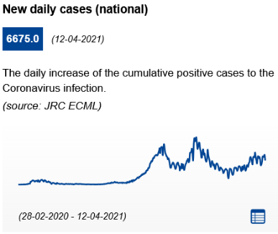 | Infection rate (cumulated past 14 days): 568.13 cases per 100.000 inhabitants (up from 290.49 cases per 100.000 inhabitants on 17.03.2021)  On 04.04.2021, 12,01% of the population received at least one dose of Covid-19 vaccine.  General information: On 13.04.2021, the government announced a plan to reopen the society steps by step. The first step of the reopening plan will not be taken until at least 28.04.2021. On 20.04.2021 the government will announce whether this step can go ahead on 28.04.2021, depending on the number of new hospital admissions. The strict current measures remain in place until that time. The second step will not be taken until at least 11.05.2021.  There is a national curfew between 22.00 and 05.30. During these hours people may only leave the house for essential purposes and need to carry a certificate as proof. The curfew should be lifted as of 28.04.2021.  People are advised to stay at home as much as possible. People may host no more than 1 guest in their home, garden or balcony per day, and may only go outdoors alone (or with members of the same household). As of 28.04.2021, people should be allowed to receive two visitors a day at home instead of one. People are asked to travel as little as possible within the country, limit the number of outings and avoid busy places, avoid travelling and booking trips abroad until 15.05.2021, unless the journey is essential (holiday travel and family visits are not essential). General advice to work from home, unless this is really not possible.  Supermarkets, bakeries, pharmacies, gas stations, postal services, animal care shops, banks, car shops, dry cleaners, and tailors are considered essential shops and can remain open. Non-essential shops can offer a pick-up point outdoors, and are allowed to host customers by appointment, with a maximum of two customers per floor, and maximum 6 customers per hour in total. Non-essential shops should be allowed to reopen as of 28.04.2021. Ban on alcohol sales and consumption in public spaces from 20:00 to 07:00. Other contact-based professions, such as hairdressers and pedicures, are allowed to operate. Swimming pools, saunas, spas and gyms are closed.  Health protocols for tourism services and tourists. Recommended contact tracing app: CoronaMelder app  Hotels: Tourist accommodations are open. Campsites and holiday parks are open. However, establishments are not allowed to serve food or drinks. Hotel guests may pick up their food order in the hotel, but must eat in their room;  Bars and restaurants: Restaurants, cafés and outdoor seating areas are closed. Take-away will still be possible until 01:00. Customers should only enter an establishment to pick up their order. Using slot machines is not allowed. Alcohol may not be sold after 20.00. Cannabis cafés must close at 20.00. Outdoor seating areas at restaurants and bars should be allowed to reopen, under certain conditions, as of 28.04.2021.
Norway  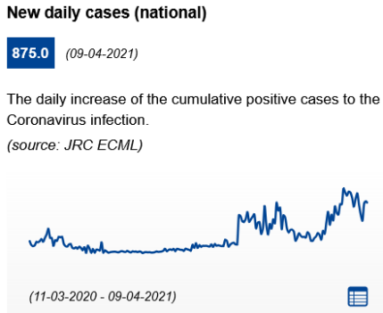 | Infection rate (cumulated past 14 days): 126.76 cases per 100.000 inhabitants (up from 118.29 cases per 100.000 inhabitants on 17.03.2021)  On 11.04.2021, 16,03% of the population received at least one dose of Covid-19 vaccine.  General information: Localities may apply stricter rules than those in place at national level. Domestic travel that is not strictly necessary is discouraged. Travels in connection with work that are considered necessary can be carried out.  The use of masks is not required in public but recommended in public transport and only mandatory in air transport. Social distancing of minimum 1 metre. No more than 10 participants at a private event at a public (rented or borrowed) venue. No more than 10 participants at a public indoor event without designated seating. No more than 100 participants at a public indoor event with designated seating. Gathering at a private venue: maximum 2 guests in addition to those who are part of your own household.  In areas characterized by a higher epidemiological risk, further restrictions may apply and the use of face masks is mandatory on public transport to/from and within the region as well as inside public places such as shops and malls where it is not possible to keep a distance of one metre from other people.  Non-essential shops, cultural venues and personal care services may remain open. In areas characterised by a higher epidemiological risk, further restrictions may apply.  Hotels can remain open. Persons who are not permanent residents (as per the National Population Register) or do not have a suitable place of residence to implement their travel quarantine, must complete their quarantine duty period at a quarantine hotel.  Bars and restaurants: In restaurants, bars and cafés a distance of at least one metre between seated people has to be kept, apart for members of the same household. A requirement on contact details registration is in place. In areas characterized by a higher epidemiological risk, further restrictions may apply, such as no serving of alcohol after midnight or closure time at 22:00 in order to reduce the number of visitors during the evening. Requirements for serving food and alcohol
Poland  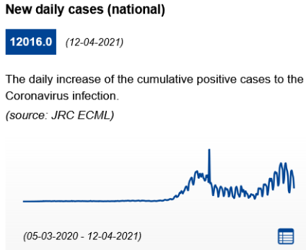 | Infection rate (cumulated past 14 days): 839.24 cases per 100.000 inhabitants (up from 615.15 cases per 100.000 inhabitants on 17.03.2021)  On 12.04.2021, 14,98% of the population received at least one dose of Covid-19 vaccine.  General information: The stricter rules introduced on 20.03.2021 are extended until the 25.04.2021. In the provinces of Pomorskie and Warmińsko-Mazurskie, stricter measures apply: schools, hotels, museums, cinemas, shopping centres and sports facilities are closed. Elderly people are strongly recommended to stay at home and move only for essential reasons. Seniors are asked to stay at home, especially above 70, under certain exceptions.  Wearing masks is compulsory in public places across the country. Gatherings are limited to 5 people maximum. Weddings, communions, consolations and other special celebrations are suspended.  As of 20.03.2021, only a very limited number of establishments and services will be open. Shops will close with the exception of: grocery stores, pharmacies and drugstores, press salons, bookstores, pet stores and DIY stores, hairdressing, optics, banking, laundry services.  Health protocols for tourism services and tourists (in Polish) Recommended contact tracing app: ProteGO Safe.  Hotels are in principle suspended and guests may only be allowed under strict conditions. Hotel restaurants remain closed, meals can only be served in rooms. Hotels might reopen to tourism as of 04.05.2021.  Bars and restaurants: are closed and only takeaway and delivery options are in function.
Portugal  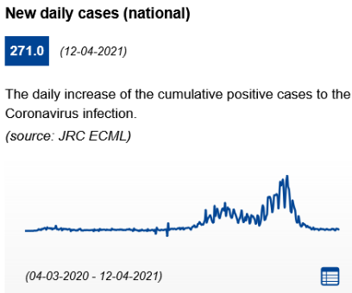 | Infection rate (cumulated past 14 days): 45.94 cases per 100.000 inhabitants (stable from 38.8 cases per 100.000 inhabitants on 17.03.2021)  On 12.04.2021, 15,44% of the population received at least one dose of Covid-19 vaccine.  General information: Strong restrictions remain in force for all the continental national territory. On 15.03.2021, the Government established a ‘Plan for Deconfiguration’, crossing several scientific criteria, divided into four phases and with a period of 15 days between each phase, in order to be able to assess the impacts of the measures on the evolution of the pandemic. New phases of reopening are planned on 19.04.2021 and 03.05.2021.  In general, people are required to stay at home, with a few exceptions: purchase of essential goods and services, the performance of professional activities when teleworking is not possible, attendance at school establishments, compliance with the sharing of parental responsibilities.  In public places, physical distance of 10 square meters of area per person and a distance of 2 metres between people is required. Facemasks are mandatory in all other outdoor spaces and workplaces where it is not possible to maintain 2 metres distance and when people are not from the same household. Celebrations and other events are prohibited, with the exception of religious ceremonies.  Non-essential shops are closed but may offer deliveries or pick-up as of 15.03.2021. Personal care services may also reopen as of 15.03.2021. Shops up to 200 m2 big with a door to the outdoors are open since 05.04.2021. All shops and shopping centres might reopen as of 19.04.2021.  Recommended contact tracing app: StayAway COVID  Hotels: may open with the adoption of the "Clean & Safe" seal which identifies of establishments and services that have implemented enhanced hygiene and safety measures.  Bars and restaurants are closed. Takeaway and delivery are allowed. Terraces outdoors (max 4 people per table) are open since 05.04.2021. They might reopen (with max 4 people per table or 6 in a terrace outdoors) with limited hours as of 19.04.2021 and with no time-limit (but max 6 people or 10, per table, on terraces) as of 03.05.2021.
Romania  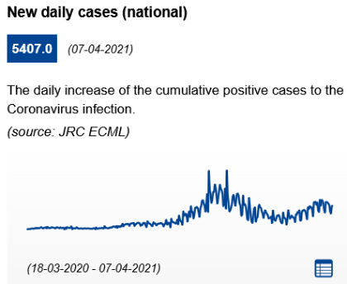 | Infection rate (cumulated past 14 days): 388.79 cases per 100.000 inhabitants (upe from 332.59 cases per 100.000 inhabitants on 17.03.2021)  On 12.04.2021, 12,09% of the population received at least one dose of Covid-19 vaccine.  General information: Since 09.11.2020, free movement is only allowed between 05.00 to 23.00. Movement outside these hours is only permitted for work, medical care, caring responsibilities, and due to fixed transport schedules (plane/train/coach). It is required to carry proof (for example, work badge, affidavit, travel itinerary) of the need for such movements. Certain areas are subject to stricter quarantine measures.  The use of face masks is mandatory in indoor and outdoor public spaces for anyone aged above 5. Social gatherings are discouraged. It is prohibited to organise private celebrations and events in closed spaces. Private groups cannot be larger than 6 persons. Rallies and demonstrations can take place with maximum 100 participants, and under strict regulations.  Shops, shopping centers, and markets should close at 21.00. Pharmacies and gas stations can remain open longer. Deliveries are permitted without time restrictions. Gyms and beauty salons can operate between 05.00 and 21.00 with special protective measures in place.  Recommended contact tracing app: CovTrack  Hotels: are open, maintaining social distancing Wearing a mask is mandatory. Hotel catering services can operate at 50% capacity and only between 06.00 and 23.00 hours in counties where the cummulative infection rate in the past 14 days is lower or equal to 1.5 per 1000 inhabitants. Lower capacity may apply according to infection rates (see below).  Bars and restaurants: Between 06.00 and 23.00, restaurants and cafes can operate at 50% capacity in counties where the cummulative infection rate in the past 14 days is lower or equal to 1.5 per 1000 inhabitants. Visitor capacity is reduced to 30% for counties where the cummulative infection rate in the past 14 days is higher than 1.5, and lower than 3 per 1000 inhabitants. In counties where the cummulative infection rate in the past 14 days is higher than 3 per 1000 inhabitants, these services are suspended.
Serbia  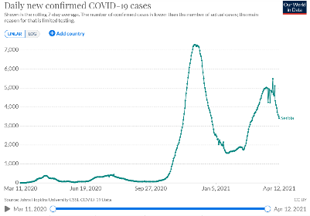  * 3399 new cases recorded on 12.04.2021 | Infection rate (cumulated past 14 days): 876,86 per 100.000 inhabitants (down from 912.57 cases per 100.000 inhabitants on 17.03.2021)  On 10.04.2021, 25,23% of the population received at least one dose of Covid-19 vaccine.  General information: On 16.03.2021, Serbia's government announced that it has no plans to introduce a curfew or to limit the free movement of citizens. Additional rules and penalties vary in different towns and cities, and rules can change rapidly. Working from home is strongly encouraged. The government eased some measures on 05.04.2021.  Protective face masks are mandatory in all public spaces, both indoors and outdoors when the area is crowded. Failure to wear a mask when required will incur a fine. Self-isolation, when required, will be enforced. Indoor and outdoor gatherings are limited to 5 people. Work organisations, schools, shops, shopping malls and similar are excluded from this but must limit numbers of customers to 1 person per 4sqm. Theatres and some cultural events are permitted to operate with restricted numbers.  All businesses and services that are allowed to work, may operate from 6:00 a.m. to 10:00 p.m.  Non-essential shops remain open whereas shopping malls might reopen as of 12.04.2021.  Hotels are open. Restaurants within hotels may serve to registered guests until 9pm.  Bars and restaurants with gardens and patios may operate only outdoors with strict observation of all epidemiological measures, including a limit of five people per table with a mandatory two-meter distance between tables as of 05.04.2021. Cafes, bars, and restaurants without gardens and patios remain closed. Deliveries are possible at all hours.
Slovakia  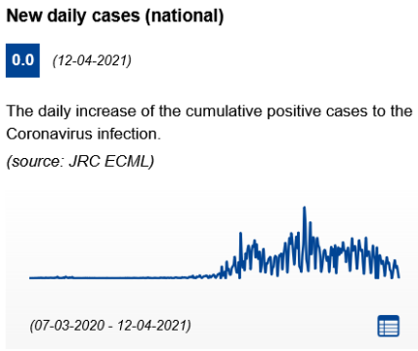 | Infection rate (cumulated past 14 days): 237.54 cases per 100.000 inhabitants (down from 501.08 cases per 100.000 inhabitants on 17.03.2021)  On 12.04.2021, 15,95% of the population received at least one dose of Covid-19 vaccine.  General information: A national lockdown has been imposed: people may only leave home for essential reasons between 5am and 8pm. A night curfew applies between 20:00 and 8:00 (as of 30.03.2021; before: 1:00)- as of 03.03.2021 until further notice. The Pandemic Commission has recommended the government prolong the national emergency by another 40 days. Obligations may differ between regions of Slovakia and different dates based on the level (tiers 1 to 4) of the warning system according to the ‘COVID automat’. Travelling to another district for leisure, recreation or sport is not allowed.  FFP2 masks are mandatory in all indoor areas except households. Mass and sport events are forbidden. Exceptions to these prohibitions are one-off mass events, where all participants are required to have a negative RT-PCR test for Covid-19 not older than 12 hours from the beginning of the mass event and which will be reported to the locally competent regional public health office no later than 48 hours. Hygiene and social distancing measures must be in place.  Non-essential shops are closed. In essential shops, maximum of 1 customer per 15 m2 is allowed; only persons with a body temperature of 37 °C or less may enter. Wellness and fitness centres as well as natural and artificial swimming pools must remain closed.  Hotels: Hotels are open only to guests that are travelling for work & business purposes, or for the purpose of visiting a medical facility. Consumption of food and drinks in the common areas is prohibited.  Restaurants and bars: Indoor catering establishments are closed. Restaurants can sell food and drinks as take-away.
Slovenia  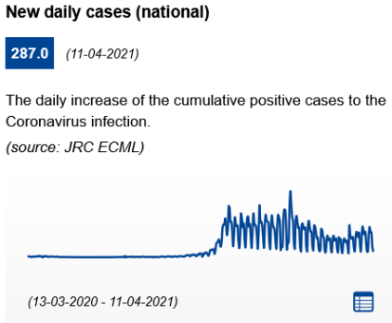 | Infection rate (cumulated past 14 days): 663.89 cases per 100.000 inhabitants (up from 528.57 cases per 100.000 inhabitants on 17.03.2021)  On 12.04.2021, 16,10% of the population received at least one dose of Covid-19 vaccine.  General information: The movement and gathering of people have been temporarily restricted in Slovenia. As of 12.04.2021, the movement of people on the entire territory of the Republic of Slovenia between 22:00 and 05:00 has been lifted. However, the movement between municipalities with certain exceptions for which adequate proof is still in place. Persons crossing a municipal boundary must carry with them adequate proof of the exception justifying their travel and a signed and legible statement. Additional local and/or regional restrictions can apply.  Masks must be worn in all closed and open (if social distancing cannot be ensured) public spaces. The temporary ban on gathering (socialising) of more than ten people is extended throughout the territory of the Republic of Slovenia, except for persons who are close family members or share the same household subject to restrictions and prohibitions imposed by this Decree.  Non-essential shops and services are not allowed. The offering and sale of goods and services in essential shops as well as personal care services (§e.g. hairdressers) require that employees are tested once a week. All employees must be tested, including those who do not have direct contact with consumers. Since 27.02.2021, additional restrictions on the sale of goods and services apply in the Coastal-Karst region.  Recommended contact tracing app: #OstaniZdrav  Hotels: Accommodation facilities remain closed. Transactions with legal entities are permitted (e.g. a company can procure accommodation with an accommodation provider for their business partners or workers).  Bars and restaurants: Inns, restaurants, pubs, cafés, confectioners, snack bars and bars remain closed. Food and beverages can be personally collected from designated takeaway locations from 6 am to 9 pm. The collected food and beverages cannot be consumed at the designated takeaway locations. he ban does not apply to catering activities in accommodation where catering activities may be carried out between 06.00 and 22.30, but only to guests staying in accommodation establishments.  Food and drinks are allowed to be served at outdoor terraces of catering establishments in the Jugovzhodna Slovenija and Posavska regions between 6am and 7pm. Guests must leave the terrace of a catering establishment no later than 30 minutes after the permitted closing time. Table service is permitted only if a minimum distance of 1.5 m between customers and 3 m between table edges is observed. A maximum of four people are allowed at each table.
Spain  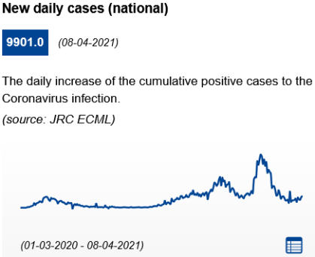 | Infection rate (cumulated past 14 days): 87.81 cases per 100.000 inhabitants (down from 530.26 cases per 100.000 inhabitants on 17.03.2021)  On 12.04.2021, 16,42% of the population received at least one dose of Covid-19 vaccine.  General information: National curfew between 23.00 and 06.00 in place, Canary islands excluded. Autonomous regions have the authority to start the curfew an hour earlier, or later. Further regional and local restrictions can apply. There are multiple regions, provinces, and municipalities that are subject to a perimetral lockdown, meaning residents cannot leave or enter the area unless it is for essential reasons, such as for work, to access care services, or in the case of a medical emergency.  Face masks are mandatory in public spaces, indoors and outdoors. Outdoor social gatherings are limited to 6 people. Physical distancing measures must be guaranteed and the maximum precautions must be taken to avoid meetings and overcrowding in indoor places.  Shops are open. Shops must ensure that disinfection measures and social distancing are applied. Special attention is required in commercial areas and street markets. Restrictions can differ between autonomous regions.  The contact tracing app Radar Covid is currently being rolled out in regions across Spain after a pilot test in La Gomera.  Recommendations from the Spanish government for the service industry (in Spanish).  Hotels: are open, but occupancy is often limited, and there can be restrictions on valet parking and ironing services. In-house catering services have to comply with the general disinfection and social distancing measures, as well as restricted opening hours. There may be temporary limitations on the number of guests per table. Measures may be changed when necessary to respond to the local COVID-19 situation.  Bars and restaurants: Many restaurants, bars and cafés have limited opening hours. Depending on the local situation, opening hours can be further restricted, or services can be cancelled completely, except for home delivery and take-away. For restaurants, in general, a maximum of 10 guests is allowed per table. Booking in advance is recommended. Stricter limits may be enforced as necessary. It is forbidden to smoke in the open air when a safety distance of 2 metres cannot be maintained.
Sweden  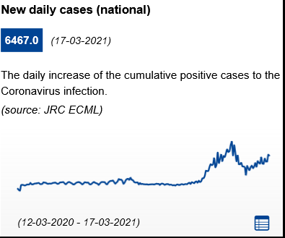 | Infection rate (cumulated past 14 days): 382,73 cases per 100.000 inhabitants (up from 338.52 cases per 100.000 inhabitants on 17.03.2021)  On 09.04.2021, 13,43% of the population received at least one dose of Covid-19 vaccine.  General information: Sweden is postponing its planned easing of the restrictions until May at the earliest, given the arrival of the third wave in the nation. Sweden is the only EU country not to have enacted a general lockdown or curfew measures since the outbreak of the pandemic, though measures were being considered in late February. Sweden has adopted a set of general guidelines to avoid the spread of Covid-19  Crowding must be avoided. People are asked to refrain from traveling as much as possible Public gatherings and events may have a maximum of 8 participants. There is no general requirement to wear a face mask in normal social situations, in public places, and in public transport, but their use is highly recommended since 07.01.2021.  Non-essential shops, except for shopping malls, and personal care services are open, but may have reduced opening hours and limits to the number of customers allowed. Many museums and theatres are closed but open-air alternatives may be open.  Hotels: are open but measures to reduce the risk of infection must be in place, such as arrangements to avoid queuing, a limit to the number of guests, social distancing, and hygiene measures. If there is a restaurant, bar, café or similar facility at the accommodation, it will be covered by the new rules for restaurants and bars.  Bars and restaurants: are open under certain conditions. No crowding is allowed. Guests must respect physical distancing; food and drinks must be served at the table; guests must always eat their food while seated at a table; takeaway food can be purchased, as long as no crowding occurs. There is a limit of 4 people per table. The serving of alcoholic beverages and alcoholic beverage-like preparations is prohibited after 20:00.  Visita has launched a campaign that consists of three brochures including measures preventing infection in restaurants, hotels and campsites: Information for restaurants
Switzerland  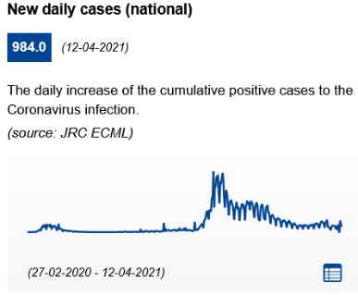 | Infection rate (cumulated past 14 days): 287.49 cases per 100.000 inhabitants (up from 197.28 cases per 100.000 inhabitants on 17.03.2021)  On 07.04.2021, 12,11% of the population received at least one dose of Covid-19 vaccine.  General information: The government will give new announcements on the 14.04.2021. Homeworking is compulsory in all areas where it is possible to work at home without disproportionate effort. Cantons may enact stricter rules and restrict movement (no federal restrictions).  Face masks are compulsory in all indoor spaces and busy outdoor areas. The number of people allowed to attend events among friends and family (for example gatherings and parties) is limited. The numbers include children. Rule indoors: a maximum of 10 people (before 5) is allowed; rule outdoors: maximum of 15. These rules only apply to gatherings of family and friends. Events such as club gatherings, a meeting or event in the parish community are still prohibited.  As of 01.03.2021, all shops may open for business again. There are no longer any restrictions on opening hours for service businesses. However, there are limits on the number of customers allowed in shops and service businesses. Cinemas, casinos, fitness centres and public spa facilities remain closed.  Recommended contact tracing app: swisscovid-app. The "Clean & Safe" campaign establishes safety protocols for service providers.  Hotels: are open. Hotel facilities (e.g. spas and restaurants) are open for hotel residents only.  Restaurants and bars: Catering businesses are closed. Takeaways and delivery services are permitted.
Turkey  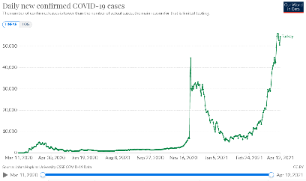  * 54562 new cases recorded on 12.04.2021 | Infection rate (cumulated past 14 days): 786.1 cases per 100.000 inhabitants (up from 242.4 cases per 100.000 inhabitants on 17.03.2021)  On 12.04.2021, 13,17% of the population received at least one dose of Covid-19 vaccine.  General information: Provinces in Turkey are split into four tiers by COVID-19 risk: low, medium, high and very high. A map of Turkey illustrating these tiers is available from the Ministry of Health.  Nationwide overnight curfews are in place from 9pm until 5am the following morning. For high risk areas, the curfew will also last from Saturday at 9pm until 5am Monday morning. And for very high risk areas, the curfew will also last from Friday at 9pm until 5am Monday morning. During the upcoming Ramadan holiday, the Turkish government has announced a lock-down throughout the entire Ramadan holiday and weekend from 12.04.2021 until 16.05.2021.  Turkish citizens and residents must request a HES (Hayat Eve Sigar) Code for domestic and international flights, train and ferry travel. Some provinces also require submission of a HES code upon entry to public buildings, shopping malls and banks. This does not apply to foreign tourists. In high and very high risk areas, curfews remain in place for those aged over 65 or under 20s. All persons nationwide must wear protective facemasks and observe social distancing while in public. Strict social distancing guidelines have also been imposed on public transport.  Swimming pools and football pitches will be open from 9am to 7pm in low and medium risk areas. They remain closed in high and very high risk areas.  Shopping centres, markets, restaurants and hairdressers will be open from 10am to 8pm throughout the week. A range of measures remains in force outside curfew hours.  Hotels are open. Restaurants in hotels/accommodation facilities will be open; however, they will be available for hotel guests only. Since 30.09.2020, the HES code will also be required for Turkish nationals or residents when checking into accommodation.  Bars and restaurants: with the exception of very high risk areas, restaurants and cafes will be open from 7am to 7pm for sit down service. Capacity will be limited to 50%. After 7pm, and in very high risk areas, restaurants will only be providing takeaway services. During the month of Ramadan, restaurants and cafes in Turkey will only be allowed to deliver food.
United Kingdom  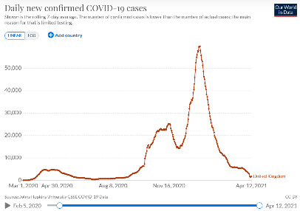  * 1666 new cases recorded on 12.04.2021 | Infection rate (cumulated past 14 days): 53.7 cases per 100.000 inhabitants (down from 118.67 cases per 100.000 inhabitants on 17.03.2021)  On 11.04.2021, 47,42% of the population received at least one dose of Covid-19 vaccine.  General information: the four home nations (England, Scotland, Wales and N. Ireland) apply measures differently. Lockdown restrictions have begun to be eased across the UK and several stages are planned. All four home nations however remain under strict lockdown rules for the moment.  In England, easing of restrictions began on 29.03.2021. People are allowed to meet outside, either with one other household or within the "rule of six", including in private gardens. The stay at home rule ended, but the government still urges people to stay local as much as possible. As of 12.04.2021: all shops reopened, along with close-contact services, including hairdressers and beauty salons (including in people's homes), and gyms and spas. Members of the same household will be able to take a holiday in the UK in self-contained accommodation. As of 17.05.2021, further lifting of restrictions may happen, including reopening of hospitality establishments for indoor services, and International leisure travel may resume. Even further lifting of restrictions may happen on 21.06.2021.  In Scotland, the Stay at Home order is finally set to be lifted on 02.04.2021, initially replaced by a Stay Local message. As of 26.04.2021, there will be a return to the "levels" system of local restrictions, with the whole country in level three from zero to four). On 05.04.2021, hairdressers and barbers can reopen, and Click-and-Collect resumes for non-essential retail after an 11-week suspension. As of 26.04.2021, restrictions on movement in mainland Scotland will be lifted entirely - although if rules on hospitality and socialising are lifted more quickly in island communities, some limits on travel to and from them may remain. Non-essential journeys to other parts of the UK and the wider common travel area should also be permitted.  Wales has lifted ‘stay at home’ orders but remains under maximal level alert. All shops, including all close-contact services, will be able to open as of 12.04.2021. The ban on travelling in and out of Wales has ended. Further restrictions will be lifted on 26.04.2021, 03.04.2021 and 17.04.2021. Northern Ireland will begin easing rules as of 01.04.2021.  Hotels: Hotels in England may reopen on 17.05.2021, and as of 26.04.2021 in Scotland. Self-contained accommodation in Wales will be able to reopen provided case rates remain low as of 27.03.2021.  Bars, pubs, cafés and restaurants: In England, restaurants and pubs could be allowed to serve food and alcohol to customers sitting outdoors as of 12.04.2021 and indoor service may again be possible as of 17.05.2021. Nightclubs will be allowed to reopen possibly in June.  In Scotland, as of 26.04.2021 pubs, bars, cafés, restaurants and bars will be able to serve people outdoors - in groups of up to six from three households - until 22:00. Alcohol will be permitted, and there will be no requirement for food to be served. There will also be a partial resumption of indoor hospitality - food and non-alcoholic drinks can be served until 20:00 for groups of up to four people from no more than two households. Contact details will still need to be collected. Indoor hospitality is expected to resume with alcohol being served and pubs or restaurants allowed to stay open until 22:30 with two-hour time-limited booking slots as of mid-May.
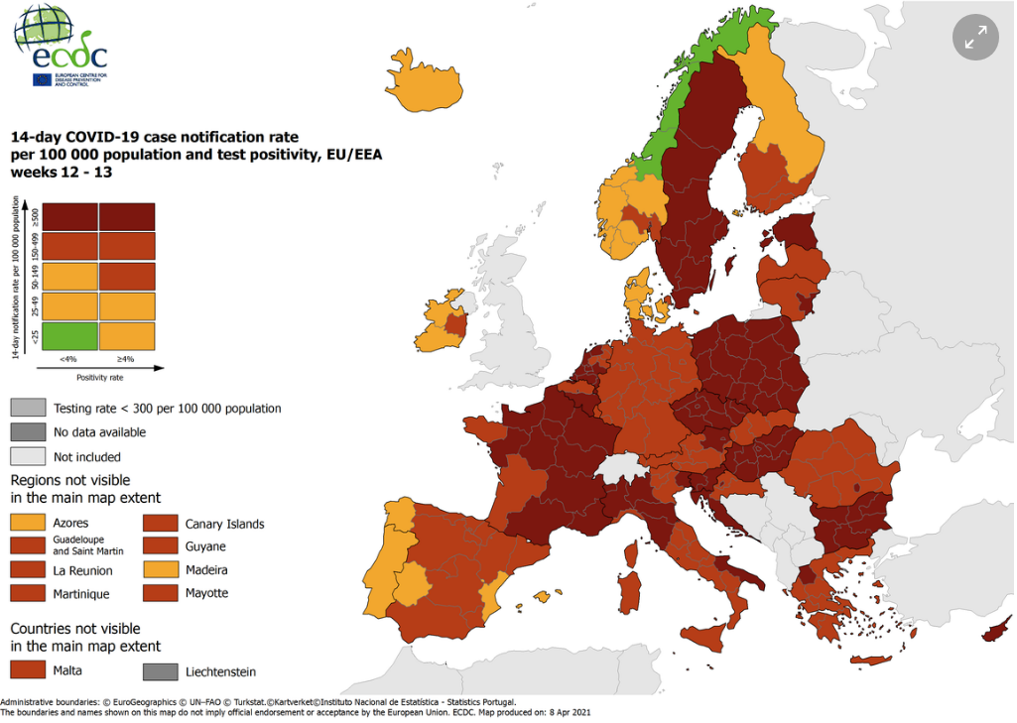
Combined indicator: 14-day notification rate, testing rate and test positivity, updated 13 April 2021.
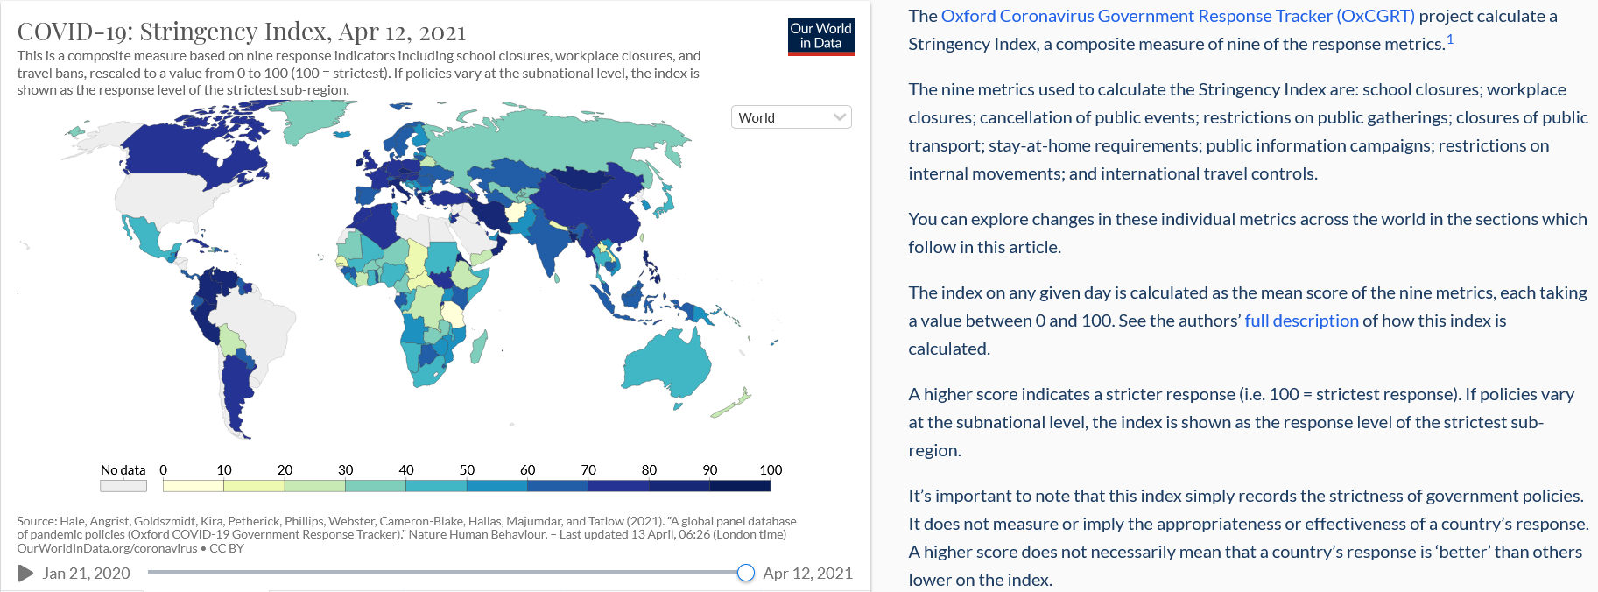
https://ourworldindata.org/covid-government-stringency-index

