Global Roadmap on Food Waste Reduction in the Tourism Sector

# 1.0 Foreword

*UNWTO/One Planet*

*“Setting a common vision for the tourism sector to address food waste”*

# 2.0 Executive Summary

*To include:*

*Demonstrating support for the Global Roadmap, importance of taking action.*

# 3.0 Introduction

*To include:*

1. Set the scene. Food waste - SDG 12.3 / climate change/ biodiversity loss / changing societies e.g. pandemics. The need to build a resilient future of our societies.
2. Where does the tourism sector stand?
3. Why is a roadmap needed?
4. Explain reasons for targeting accommodation and cruise sectors in the first instance.
5. From the COVID 19 recovery – in line with One Planet Vision for a Responsible Recovery from COVID-19 to the green transformation of the sector – in line with UNWTO G20 Recommendations for the transition to a green travel and tourism economy.
6. Introduce it is about saving business money and delivering real benefits for the environment and climate, not just reporting data for the sake of data.
7. Introduce framework of Target Measure Act report as a proven approach to delivering impact.
8. Define Target, Measure, Act (TMA)
9. Introduce logic/ flow of Roadmap and the 4 Commitments.

# 4.0 The Global Roadmap

## 4.1 Objective

*To include:*

1. Provide a consistent framework accelerate food waste reduction in tourism.
2. Share practical guidance for accommodation and cruise to scale up action.
3. Support the integration of circularity in the tourism food value chain.
4. Enhance the contribution of tourism to the achievement of SDG12.3.
5. Links with the Glasgow Declaration.

Sustainable Development Goal (SDG) 12.3 sets out to achieve:

*By 2030, halve per capita global food waste at the retail and consumer levels and reduce food losses along production and supply chains, including post-harvest losses.*

## 4.2. Scope

*To include:*

1. Introduce supply chain. Reference WRI report for further information
2. Introduce FW and Food Loss
3. Introduce inedible parts
4. Confirm scope is for FW only
5. Confirm FW includes drink/ liquid
6. Confirm aimed primarily at accommodation and cruise sector but all sectors can adopt as guiding principle

The scope of the Roadmap in relation to the food value chain is shown below.

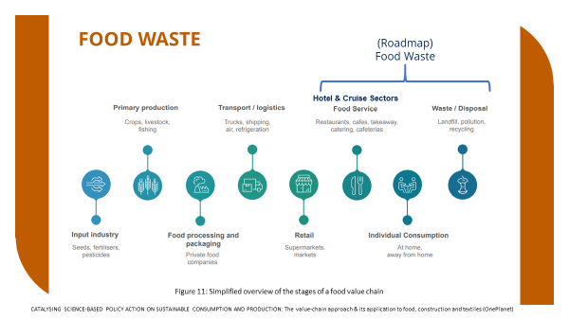



4.3 Food and Drink Material Hierarchy

*To include:*

Introduce hierarchy

Priority is Prevention

Introduce surplus and redistribution

Introduce components of food waste – preparation, spoilage, plate and other waste

Introduce diversion from landfill (Following feedback from/ consultation with AG desire to consider diversion from landfill – which doesn’t contribute to delivery of SDG 12.3 but has benefit to climate change)

Introduce components of diversion (destinations)

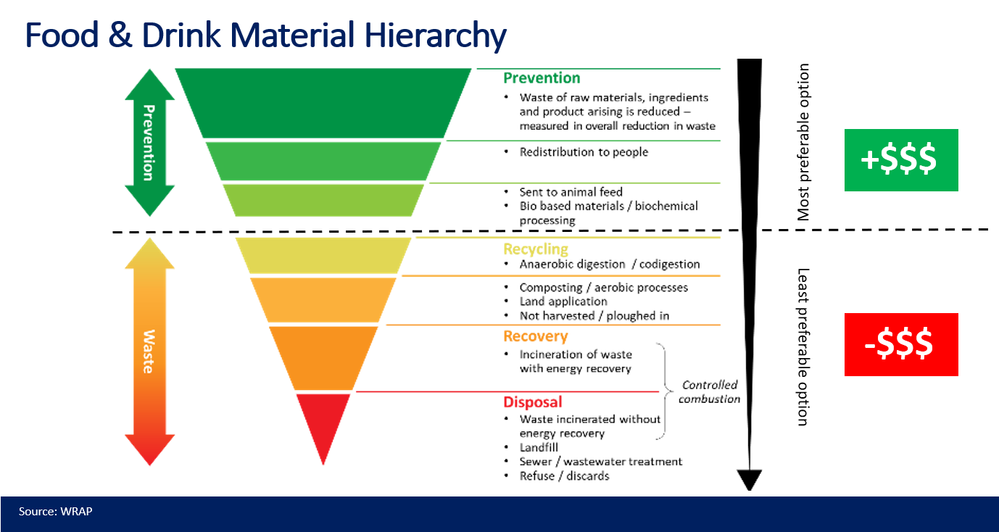

# 5.0 Business Case

*To include:*

1. *Stakeholder example of benefits to business of setting targets, measuring and taking action.*
2. *Pull on WRi Reports on business case, updated if possible.- WRAP*
3. *Embodied carbon example between prevention and diversion (equivalences and, if available, references to coefficients to calculate)*
4. *Quotes from senior business leaders - UNWTO/One Planet*
5. *Reinforce it is about saving business money and delivering real benefits for the environment and climate not just reporting data for the sake of data. Act now to build resilient future for your business and the planet.*
6. *Supported by mini/ pen portrait business case studies*

# 6.0 Targets and Milestones

## 6.1 Prevention Target

To accelerate the reduction of food waste in tourism operations through prevention, the Roadmap proposes the following targets:

***Accommodation Sector -*** ***By 2030, halve site level food waste per guest night***

***Cruise Sector - By 2030, halve ship level food waste per guest day***

The target is an overarching target, aligned with SDG 12.3, replacing per capita with guest/night and guest/day[1] making it more relevant to the sectors under consideration. This allows better benchmarking and monitoring of progress in real terms, mitigating for any significant changes in occupancy as experienced as a result of circumstances beyond the business’ control e.g. the Covid-19 pandemic. Section 7 sets out the measurement process, metrics and how, by using readily available or accessible data progress against the above intensity metric can be demonstrated.

***COMMITMENT 1: TARGET - PREVENTION***

*Organisations committing to the Roadmap are asked to set a food waste reduction target for their own operations: 50% by 2030 or a different target that contributes to the Roadmap.*

### 6.1.1 Scope of Prevention Target

Prevention of food waste includes avoidance in the first instance and then any material that is sent for redistribution to people, animal feed or conversion into industrial products. For the purposes of the Target the stages of the food value chain that fall under your “own operations” are from receipt of food goods at the site/ ship to disposal from the site/ ship.

### 6.1.2 Targets other than 50%

There are valid reasons why a business may not be able to adopt a 50% reduction target – e.g., where a business has made significant efforts in the past to reduce food waste but cannot fully evidence these. Alternative targets which contribute to the Roadmap target should be ambitious and supported by evidence.

### 6.1.3 Should this be a relative or an absolute target?

At a global level, SDG 12.3 aims to reduce food waste by 50% per capita, meaning that it is a relative target. When applied to your organisation the target should also be relative – e.g., a 50% reduction in the amount of food waste per guest. For example, if your baseline is 0.32 kg of food waste per guest, your target would be to achieve 0.16 kg by 2030.

### 6.1.4 What should be the baseline year for the target?

Set your baseline year as the earliest year for which comparable historical data are available. Ensure that the data are robust and consistent. If comparable historical data are not available then begin measuring and develop a baseline as soon as possible, noting that you will be required to have established your baseline within 18 months of your commitment. Note that if you are unsure as to whether your baseline is representative then it is permissible to re-visit and re-set your baseline as more accurate data becomes available or the scope of measurement is extended.

## 6.2 Diversion Target

Even with the best food waste prevention measures in place it is likely that an element of food waste will occur. Good management of the food waste produced is essential to reduce its environmental impact. This management should focus on moving food waste up the hierarchy (Fig YY) by diverting from landfill or discharge to sea to more beneficial and circular solutions such as segregating food waste and diverting to composting or anaerobic digestion where infrastructure exists.

If you are currently sending food waste to landfill and/ or discharging to sea you should also adopt the following diversion target:

***COMMITMENT 1A: TARGET - DIVERSION***

*If not already achieved, organisations committing to the Roadmap are additionally asked to set a food waste diversion target for their own operations:*

*Accommodation Sector - divert 100% of food waste from landfill or where the infrastructure does not exist divert 50% by 2030;*

*Cruise Sector - increase capacity on-board to process 100% of residual food waste, avoiding the need to discharge to sea.*

*Alternatively, businesses can set a different target that contributes to this area of the Roadmap.*

***Advisory Group Note:*** *Targets should be SMART (refer to Section 6.3). It is acknowledged that the cruise sector target is challenging particularly when considering international catering waste (ICW). We would welcome further input from the AG to ensure the target is both Accepted and Realistic. WRAP to provide an update at the AG Meeting on the 4th May but pleased to discuss/ receive comments in advance.*

### 6.2.1 Scope of Diversion Target

In accordance with the food waste and drink hierarchy (Section 4.3) diversion from landfill or discharge to sea would include energy recovery, incineration, composting and anaerobic digestion.

### 6.2.2 Target setting where infrastructure does not exist for separate treatment of food waste

Where there is no infrastructure available to enable diversion from landfill/ discharge to sea then the focus should again be on prevention of the creation of food waste. The targets are complimentary in that delivery against the prevention target will automatically deliver against the diversion target but with significant economic, social and environmental benefits over diversion alone.

To include:

1. Local solutions , composting, case studies

## 6.3 Target Setting

Guidance on setting a target that delivers against or contributes to the Roadmap targets, together with guidance on scope, measurement is provided via the following references. Targets should be ambitious and SMART.

* **S**pecific – state exactly what will need to be done
* **M**easurable – clear what success will look like
* **A**ccepted – decided on by all participants in the process
* **R**ealistic – know it is practical – steps can be taken to do it
* **T**ime bound – state when it will be achieved.

[Food Loss and Waste Accounting and Reporting Standard | World Resources Institute (wri.org)](https://www.wri.org/research/food-loss-and-waste-accounting-and-reporting-standard#:~:text=The%20Food%20Loss%20and%20Waste%20Accounting%20and%20Reporting,much%20FLW%20is%20generate%20dand%20where%20it%20goes.)

[UK food surplus and waste measurement and reporting guidelines | WRAP](https://wrap.org.uk/resources/guide/uk-food-surplus-and-waste-measurement-and-reporting-guidelines)

[Hospitality and food service guidelines | WRAP](https://wrap.org.uk/resources/guide/hospitality-and-food-service-guidelines)

## 6.4 Milestones

All below milestones consider food waste in weight (kg, tonnes, etc.) unless otherwise stated.

### 6.4.1 Food Waste Prevention

To track progress a series of milestones have been set for the following years:

*[Option 1] 2023, 2025, 2027, 2030 (SDG12.3 end point)*

*[Option 2] 2025, 2028, 2030 (SDG12.3 end point)*

#### Individual Businesses/ Organisations

The Business/ Organisation should review progress against the following Milestones [for Option 1]

|  |  |  |  |  |
| --- | --- | --- | --- | --- |
| Status Year | 2023 | 2025 | 2027 | 2030 |
| Assuming new to subject: | Establish baseline  (18 months maximum) | 20% reduction | 35% reduction | 50% reduction |
| Already measuring: | State baseline year | 25% reduction |  | 50% reduction |

Table XX Food Waste Prevention

|  |  |  |  |  |
| --- | --- | --- | --- | --- |
| Indicator | Milestones | | | |
| **2023** | **2025** | **2027** | **2030** |
| Percentage of each signatory’s sites/ ships measuring, taking action and reporting on food waste  (i.e. implementing the Roadmap’s “Target, Measure, Act”) | 20% | 40% | 70% | >90% |

Table XXX Multi Site/ Ship Organisations

#### Trade Bodies

| Indicator | Milestones | | | |
| --- | --- | --- | --- | --- |
| 2023 | 2025 | 2027 | 2030 |
| Percentage of each Supporter’s membership committed to the Roadmap | 25% | 50% | 70% | >90% |
| Percentage of each Supporter’s membership measuring, taking action and reporting on food waste  (i.e. implementing the Roadmap’s “Target, Measure, Act”) | 10% | 25% | 50% | 75% |

Table XXXX

### 6.4.2 Food Waste Diversion

Similarly the following milestones have been set to track progress against the diversion target:

|  |  |  |  |  |
| --- | --- | --- | --- | --- |
| Indicator | Milestones | | | |
| **2023** | **2025** | **2027** | **2030** |
| Where infrastructure exists - percentage of each Roadmap signatory’s food waste sent to landfill/ discharged to sea | 25% | 10% | 5% | 0% |
| Accommodation: Where no infrastructure exists - percentage of each Roadmap signatory’s food waste sent to landfill | 90% | 80% | 70% | 50% |
| Cruise: Where no infrastructure currently exists - percentage of each Roadmap signatory’s food waste discharged to sea | 75% | 50% | 25% | 0% |

Table XXXXX

## 6.5 The Roadmap

*(Visual of above milestones. Combine Hotel, Cruise and Trade bodies on same map)*

*Example*

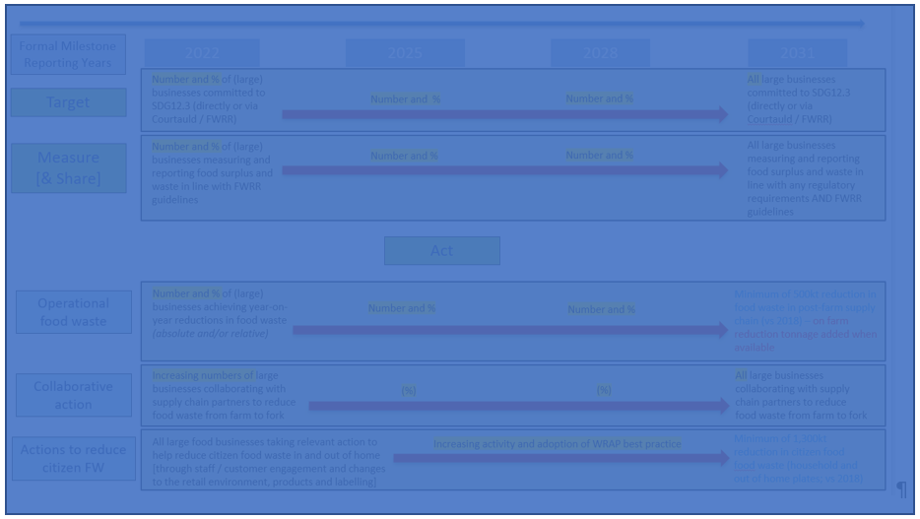

# 7.0 Measurement

## 7.1 Measurement Methodologies

Use an appropriate methodology to robustly measure food surplus and waste. You may wish to develop your own, work with your data provider or adopt an existing methodology and recording template. The methodology must work for the business such that it is readily adopted.

#### Core Recommendations

The core recommendations, for all tourism businesses, are as follows:

1. Define a 12-month time period and scope of operations*. As a minimum this should cover all operations that your business owns or controls*
2. Quantify the tonnage of food and associated inedible parts sent to each of the food waste destinations outlined in the Food Waste Hierarchy (Fig YY).
3. Express food waste in terms of food waste (kg) per guest night/day (Section 6.1)
4. Separately quantify the tonnage of food sent to the following: • Redistribution to people (e.g. through a charity or commercial redistributor) • Animal feed • Bio-based materials/biochemical processing (e.g. feedstock for other industrial products)
5. Describe your scope and methods of measurement and reporting.

The following are proven examples of good practice and provide further guidance:

### 7.1.1 Transforming Tourism Performance Monitoring Tool

The tool allows hotels and supporting organisations to collect data about resource efficiency and monitor their resource efficiency over time to see where any actions they are taking have effects. The Resource Efficiency tool also provides information that can be used to produce a baseline for the hotels and Meetings, Incentives, Conferences & Exhibitions (MICE) sector of the tourism industry in a country.

The tool is comprehensive in addressing energy, water and waste. It’s direct value for the purposes of this Roadmap is the “Food Waste” worksheet which has different levels of data input depending on the data available.

* [Resource Efficiency Data and Performance Monitoring Tool | One Planet network](https://www.oneplanetnetwork.org/knowledge-centre/resources/resource-efficiency-data-and-performance-monitoring-tool-0)

### 7.1.2 WWF

The methodology aims to provide a consistent framework the industry can use to track waste, fill in data gaps, and report annual progress against goals. It will also facilitate public reporting and industry benchmarking, supporting organizations to make progress towards best practice.

A template for monitoring progress is included in Section 5 of the Methodology

* [HotelWasteMeasurementMethodology_SEP2021_v1.0..pdf (hotelkitchen.org)](http://hotelkitchen.org/wp-content/uploads/2021/09/HotelWasteMeasurementMethodology_SEP2021_v1.0..pdf)

### 7.1.3 WRAP

WRAP and UK food businesses have agreed some common recommendations for companies in measuring and reporting food waste/surplus data, consistent with the Food Loss and Waste Accounting and Reporting Standard (FLW Standard).

* [WRAP Food waste measurement roadmap 2020 Toolkit](https://wrap.org.uk/sites/default/files/2020-10/Food-waste-reduction-roadmap-toolkit.pdf)

WRAP has also developed a global food surplus and waste reporting Data Capture Sheet (DCS) that is recommended across all sectors for any instances in which data is shared. It consolidates the key information requirements of the FLW Standard and the information that businesses will need to replicate their food surplus and waste inventory from one year to the next (i.e. details on methods, assumptions etc).

## [Food loss and waste data capture sheet | WRAP](https://wrap.org.uk/resources/tool/food-loss-and-waste-data-capture-sheet)

Where organisations are at the early stages of measurement and reporting it may be more appropriate to use the simplified “Reporting Template” worksheet.

*Note : Consideration will be given to developing a basic data capture template to facilitate reporting*

## 7.2 Metrics

Annual food waste tonnage is the minimum metric required. Whilst this is a first step it is not possible to monitor progress against the reduction target without an intensity metric. To demonstrate progress the following information is required:

Accommodation and Cruise Sectors

1. Total Food waste per annum (tonnes)
2. Total Number of Guest Days/Nights
3. Food waste (kg) per Guest

### 7.2.1 Comparable and Additional Intensity Metrics

The following are additional metrics for the Accommodation Sector identified in the [HotelWasteMeasurementMethodology_SEP2021_v1.0..pdf (hotelkitchen.org)](http://hotelkitchen.org/wp-content/uploads/2021/09/HotelWasteMeasurementMethodology_SEP2021_v1.0..pdf)

Examples from the September 2021 version of the Methodology are repeated below for convenience:

Tables 4A and 4B Comparable Absolute and Intensity Measures

|  |  |  |  |
| --- | --- | --- | --- |
| No. | Measure or Metric | Type | Unit of Measurement |
| 4 | Food Waste Per Square Metre | Comparable Intensity Metric | Kilograms |
| 22 | Food Waste Per Revenue Dollar | Additional Intensity Metric | Any unit of weight, preferably kilogram per US Dollar |
| 23 | Food Waste per Total Food Handled | Additional Intensity Metric | Percentage based on any unit of weight, preferably Metric Tonne |

### 7.2.1 Comparable and Additional Intensity Metrics

***Advisory Group Note:*** *We would welcome further input from the Advisory Group as to whether additional cruise related metrics would provide additional comparable data and if so what metrics would you recommend are included? e.g. Food Waste per gross tonnage or food waste per displacement tonnage. WRAP to provide an update at the AG Meeting on the 4th May but pleased to discuss/ receive comments in advance.*

***COMMITMENT 2: MEASURE***

*Organisations committing to the Roadmap are asked to measure their food waste across their own operations in a consistent way to enable year on year comparison of progress against their food waste prevention (and diversion) target(s).*

# 8.0 Act

There are three key action areas:

Note: Example and outline actions only, to be developed for final document

* Own Operations – Strategic, Operations, Staff
* Guest Engagement
* Supply Chain Engagement

Example actions for each area are given below. These can be adapted, developed and turned into an Action Plan Checklist. Committed businesses should review their performance against the adopted priority actions and seek to progress from Good – Better – Best and add new actions as appropriate. The checklist can be used as evidence of progress.

It is recommended that businesses undertake to deliver or develop 3 Actions (as a minimum) over a period of 6 months, review, evidence and once achieved select a further 3 actions as part of the continuous improvement cycle.

## 8.1 Own Operations

### 8.1.1 Strategic

| Ref. | Action | Delivery Mechanisms/ Resources | a)Good | b)Better | c)Best |
| --- | --- | --- | --- | --- | --- |
| 1 | a) We have committed to the Roadmap, b) have agreed a Target for food waste reduction and c) include the agreed Target in public documents e.g. CSR strategy | Commitment to Roadmap  Provide statement / logo  Action Plans  FWR Policy/ CSR Strategy |  |  |  |
| 2 | a) We have established a Baseline from measurement data, b) track progress against the Target and c) Report publicly | Reporting in line with the Roadmap |  |  |  |
| 3 | We have identified appropriate interventions and have an Action Plan in place to reduce our food waste over the next a) 6 months b) 12 months c) >12 months |  |  |  |  |
| 4 | a)We have established KPIs for senior management on food waste reduction b) review performance monthly and c) managers are assessed/ renumerated against these KPIs | Develop KPIs  (Example Clauses) |  |  |  |
|  |  |  |  |  |  |

### 8.1.2 Site - Operations

| Ref. | Action | Delivery Mechanisms/ Resources | a)Good | b)Better | c)Best |
| --- | --- | --- | --- | --- | --- |
| 1 | a) We know and b) have mapped out where our food waste comes from e.g. deliveries, kitchen, c) including buffet, overproduction and plate waste | WWF Hotel Kitchen |  |  |  |
| 2 | We measure, record and report our food waste a)periodically b)regularly c)daily | Paper based tracking sheet  Smart Meters  EPOS |  |  |  |
| 3 | b) We have agreed a Target for food waste reduction |  |  |  |  |
| 4 | a) We have established a Baseline from measurement data, b) track progress against the Target and c) Report | Reporting in line with organisation’s policy/ Action Plan |  |  |  |
| 5 | We have identified appropriate interventions and have an Action Plan in place to reduce our food waste over the next a) 3 months b) 6 months c) 12 months |  |  |  |  |
| 6 | c) Our kitchen production plans are dynamic and aim to reflect recent patterns, seasonality, weather and events |  |  |  |  |
| 7 | c) In addition to measurement we carry out food waste audits to identify the causes and opportunities for prevention/ reduction. These actions/ interventions are captured in our Action Plan |  |  |  |  |
| 8 | We reuse/ repurpose surplus food and have in place a plan/Standard Operating Procedure to safely repurpose leftovers through a) the staff restaurant b) discount apps c) new dishes | Menu Planning  Apps e.g. Too Good To Go |  |  |  |
| 9 | Where surplus food cannot be reused we have in place a plan/ Standard Operating Procedure to redistribute the surplus through charities and food banks a) locally b) regionally c) nationally | Hotel Kitchen  Local redistribution (in line with local redistribution laws) |  |  |  |
| 10 | Diversion?? |  |  |  |  |

### 8.1.3 Staff

| Ref. | Action | Delivery Mechanisms/ Resources | a)Good | b)Better | c)Best |
| --- | --- | --- | --- | --- | --- |
| 1 | Our job descriptions a) highlight our sustainability objectives b) highlight that sustainability is everybody’s responsibility c) assign specific responsibilities for sustainability | Job Descriptions  (Example Clauses) |  |  |  |
| 2 | Our staff receive induction on a) sustainability b) food waste prevention c) food waste measurement and reporting | WWF Hotel Methodology  WWF Hotel Kitchen  (Guardians of Grub)  (New guidance?) |  |  |  |
| 3 | We review food waste and empower staff to a) make positive change b) create a positive culture c) share improvement with other sites/ organisations | Suggestion Box  Kitchen Talks  Action Plans |  |  |  |

## 8.2 Guest Engagement

| Ref. | Action | Delivery Mechanisms/ Resources | a)Good | b)Better | c)Best |
| --- | --- | --- | --- | --- | --- |
| 1 | We promote our a) commitment to food waste prevention b) food waste target c) progress against our food waste target to our guests via our (reservations page) website |  |  |  |  |
| 2 | We engage guests on our commitment through a) table talkers b) menus c) display screens |  |  |  |  |
| 3 | We empower front of house staff to talk to consumers about a) ingredients b) portion sizes c) eat out boxes | Kitchen Talks  WWF Hotel Toolkit  [WWF How to talk to guests about FW](https://www.oneplanetnetwork.org/new-toolkit-wwf-how-talk-guests-about-food-waste) |  |  |  |
| 4 | We promote food waste prevention initiatives to both guests and staff to help embed the food waste reduction method at home | Love Food Hate Waste |  |  |  |
| 5 | MICE & Events?? |  |  |  |  |
|  |  |  |  |  |  |

## 8.3 Supply Chain

| Ref. | Action | Delivery Mechanisms/ Resources | a)Good | b)Better | c)Best |
| --- | --- | --- | --- | --- | --- |
| 1 | We work with our suppliers and logistics providers to identify causes of waste and to find solutions which can save money for all |  |  |  |  |
| 2 | Whole Chain Plans…. |  |  |  |  |
| 3 | Supplier Harmonised Approach/ Sustainability Dashboard… |  |  |  |  |
| 4 | Recruit suppliers as Supporters to the Roadmap…. |  |  |  |  |
| 5 | Supplier forums …. |  |  |  |  |

***COMMITMENT 3: ACT***

*Organisations committing to the Roadmap are asked* *to develop and implement an Action Plan to reduce their food waste, help guests reduce their food waste and work in partnership with suppliers to reduce supply chain waste. (The Action Plan shall be made public)*

# 9.0 Report

Businesses should publicly report their company results, or work towards this best practice, and share successes and lessons learned. As a minimum you should share your data via your website and sustainability reports. This allows you to generate reputational benefits from your actions and holds you publicly accountable for them. In the developing area of sustainability-linked finance, financial benefit may also follow in the coming years. Where appropriate your results should also be shared with your membership organisation who can publish aggregate data thereby demonstrating the sector’s progress. Data can also be shared via the [One Planet platform](https://www.unwto.org/unwto-tourism-dashboard).

Be as robust and transparent as possible. Taking this approach allows you to share your progress and can be used to demonstrate your commitment to guests, shareholders and other stakeholders.

## 9.1 Food Waste Prevention Reporting

When reporting publicly, include the following information:

* Your % food waste reduction target;
* Your baseline year and target year;
* Your total annual tonnage of food waste;
* Food waste (kg) per Guest;
* Your progress against your % food waste target – year on year and cumulatively – (see example below);
* Actions you have implement and are taking to reduce food waste.
* [separately, food surplus total annual tonnage (redistributed or sent for animal feed)]

## 9.2 Food Waste Diversion Reporting

When reporting publicly, include the following information:

* Your diversion landfill from target – either zero or % reduction;
* Your baseline year and target year;
* Your total annual tonnage of food waste;
* Your total annual tonnage of food waste sent to landfill;
* Percentage (%) of food waste sent to landfill;
* Your progress against your diversion from landfill target – year on year and cumulatively – (see example below);

### 9.3 How should I calculate and report my performance towards my target?

As part of your annual data reporting, you will need to report on progress towards your target. In the same way that your target is a relative change in the amount of food waste, you should also be reporting your progress – versus last year and versus your baseline year – as a relative change in the amount of food waste. You should state what year you are using as your baseline year.

## 9.4 Example:

## To be added to final document

***COMMITMENT 4***

*Organisations committing to the Roadmap are asked to report on annual progress implementing their Action Plan publicly via their website or sustainability report using an appropriate template and narrative.*

# 10.0 The Commitment (Template)

## Commitment

The objective of the Global Roadmap is to provide a consistent framework to accelerate food waste reduction in tourism, thereby enhancing the contribution of tourism to the achievement of SDG12.3. Further it provides the framework to demonstrate progress in **contributing** towards the delivery of the food waste reduction target.

To achieve this target, collaborative and concerted efforts to reduce food waste are required. These need to focus on:

* preventing food surplus and waste being generated in the first place,
* redistributing food surplus that does arise to feed people
* where permitted, diverting surplus (that cannot be used to feed people) into animal feed and high value biomaterial processing.

Where prevention actions have been exhausted and food waste remains, additional benefits to reduce emissions can be achieved by segregating and diverting food waste from landfill and discharge to sea.

For the global tourism sector to achieve the targets set out in this Roadmap commitment is required at all levels, from the smallest operator to the largest global operator. It is critical that there is widespread adoption of the principles of “Target, Measure, Act”.

#### The sector is therefore asked to commit to:

I/ We/ [Company Name] commit(s) to support delivery of the Global Roadmap target(s) on Food Waste Reduction in the Tourism Sector (Roadmap) [delete one if appropriate]:

***Accommodation Sector - By 2030, halve site level food waste per guest night***

***Cruise Sector - By 2030, halve ship level food waste per guest day***

To support this I/we further commit to embed the principles of ‘Target, Measure, Act’ within my/our business/ organisation as follows:

* **1. Prevention Target** – In support of the Sustainable Development Goal 12.3 (SDG12.3) target to reduce food waste by 50% by 2030 I/we have set (or will do so within 18 months) a food waste reduction target for my/our operations as follows:

XX% reduction in food waste by 20XX, using a baseline year of 20XX

(This information will be provided by MONTH YEAR)

* **1A. Diversion Target** - (Optional) I/we have set (or will do so within 18 months) a food waste diversion target for my/our operations as follows:

ZERO food waste sent to landfill and/ or discharged to sea by 20XX, OR

XX% reduction in food waste sent to landfill and/ or discharged to sea by 20XX, using a baseline year of 20XX

(This information will be provided by MONTH YEAR)

* **2 Measure** – I/we will measure our food waste across our own operations in a consistent way to enable year on year comparison of progress against the stated food waste target and where appropriate the diversion target.
* **3 Act** – I/ we will develop and implement an Action Plan to reduce our food waste, help guests reduce their food waste and work in partnership with our suppliers to reduce supply chain waste. I/we will provide evidence that the Action Plan is being implemented and progress made.
* **4 Report** – I/ we will report on annual progress publicly using an appropriate template and narrative via: (please advise as appropriate)
  + our website [LINK]
  + Sustainability/ Corporate Social Report (CSR)/ Environmental, Social and Governance (ESG) reports. [LINK]
  + One Planet platform
  + Other (please list):

The Commitment letter is accessed via the Templates (LINK) section and should be signed at Owner/ Chief Executive Officer (CEO)/ Board Level to demonstrate the necessary degree of commitment and authority to deliver against the Commitment.

# 11.0 Collaborative approaches and collective milestones

# 11.1. Why collaboration is needed

To include:

#### Businesses

The sector specific milestones that the Stakeholders can commit to specifically are summarised below:

|  |  |  |  |  |
| --- | --- | --- | --- | --- |
| Indicator | Milestones | | | |
| **2023** | **2025** | **2027** | **2030** |
| Accommodation Sector: No. of 50 largest hotel groups committed to the Roadmap  (and using appropriate measurement methodology (e.g. Hotels – WWF Methodology)) | 25 | 35 | 40 | 50 |
| Cruise Sector: No. of 10 largest cruise ship brands committed to the Roadmap  (and using appropriate measurement methodology (e.g. ……)) | 5 | 7 | 9 | 10 |
| Total No. of Organisations committed to the Roadmap (including Supporters and SMEs) | 40 | 70 | 100 | 250 |

# 12.0 Resources

## 12.1 5 full case studies

*To be added to final document*

## 12.2 Templates

*To include (TBC)*

* *Pledge document*
* *Reporting Template*
* *Action Plan Checklist*

## 12.3 References/ Guidelines

*To include*

*Existing and relevant to be listed*

*Supplementary Case Studies*

*Specific to be developed under Phase 2*

# 13.0 Definitions & Glossary

To be developed for final document

E.g.

Food waste For the purposes of this Roadmap, the term ‘Food Waste’ describes any food and inedible parts sent to any of the Food Waste Destinations listed below.

* Anaerobic digestion/ Co-digestion
* Composting/ aerobic processes
* Incineration/ controlled combustion
* Land application
* Landfill
* Discharge to Sea/ Sewer/ wastewater treatment
* Not harvested/ ploughed-in
* Other (including unmanaged disposal)

This definition excludes any material that is sent for redistribution to people, animal feed or, conversion into industrial products (collectively referred to as ‘food surplus’).

*……food’ and the associated ‘inedible parts*

1. Guest/night is a common metric for accommodation providers. Guest/day refers to “available passenger cruise days”.